Brief Description of the Organization

1. Name Of NGO | : Muktipath Unnayan Kendra (MUK)
2. Address | : Muktipath Babhan, 941 Jalilnagar, Raozan Pourashava, Raozan, Chattogram.
3. Contact Phone | : +8801819-343289
4. Established In | : 1991
5. Organization Status | : Non-Government Organization
6. Level of action | : Regional
Legitimacy of the organization in terms of legal, constituency and constitution
7. Micro-Credit Regulatory Authority Reg | : 01119-00936-00306
8. Social Services under government of Bangladesh Reg |  | : 1614
9. JSC Reg No | : CH-S-247
10. E-TIN No | : 199823391590
11. Founder | : Mohhamad Salim-A-Hossain
12. Country | : Bangladesh
13. Programme Area | : Chattogram, Bangladesh.
14. Vision, Mission & Goal | Vision  To be an outstanding financial institution that improves the living standards of the population and contributes to the economic and social development of Bangladesh.  MISSION  Creation of a society where the poor, particularly the poor women are organized and made aware and conscious of their rights and obligations. They are gradually empowered and made competent and self-reliant and are able to meet their basic needs by utilizing their own potentials and resources and their dependence on men is gradually reduced. The children are given proper care and education for their development as worthy citizen in future.  GOAL  Muktiapth Unnayan Kendra is effectively contributing for the empowerment of vulnerable people, especially poor, extreme poor and distressed women for socio-psycho-economic condition changes in their livelihood.
15. Aim & Objective | To empower poor, distressed & hardcore people in promoting their socio-economic status to lead an active & health life through group formation, social awareness building, Non-formal education, workshop, Micro-credit support against economic activities, saplings for social forestry, water aid & sanitation along with establishing their due rights in the society.  MUK was initiated with a view to evolving information and making linkage between the villagers and the government. We believed that knowledge would lead to awareness, which would further lead to self-development, empowerment and action.
16. History | We are a nont-for profit organization devoted to helping an increasing number of poor Bangladesh families rise out of poverty by providing micro-financing to help them establish or otherwise improve their own micro-enterprises.  The organization started with only one village of Raozan Upzilla under Chattogram District it is inception in 1990. A developed society where everybody enjoying equal rights without any affiliation to any politics, religion and race. A society that is free from all sorts of exploitation and deprivation where every citizen lives and work with dignity and equity.  ÒMohammad Salim-A-Hossain established Muktipath Unnayan Kendra in the late 1990s. In the beginning, Social service activities are conducted from the place of social responsibility. In the next phase, micro-finance programs are initiated to engage the underprivileged population in self employment generating income-generating activities besides social service work. Currently, basic programs including food, clothing, shelter, social and humanitarian actilvities, universal health protection, education are being conducted. Muktipath Unnayan Kendra is playing a leading role in improving the quality of life of the people by bringing the under privileged population of the country under the service through social activities and micro financing.Ó
17. Core Values of MUKTIPATH | - In achieving our goals, these are our core values;  - Honesty and Integrity  - Team work and Excellence  - Open communication and Transparency  - Commitment and Devotion  - Friendly Customer care and efficient service delivery.
18. OBJECTIVE | - To increase awareness of all level peoples specially neglected, oppressed and uprooted people of the society about their rights and dignity.  - To build the capacity of MUK staff as well as other duty bearers.  - To develop community level group by the people.  - To build good relation with social service oriented organizations as well as Government and ensure co-ordination at all level.  - To mobilize the community people and other stakes to ensure the optimum utilization of local resources.
19. Value & Principal | MUKTIPATH encourages the following values to be practiced both at individual and Organizational level  - Honesty  - Transparency and Accountability  - Mutual respect  - Creativity  - Gender sensitiveness  - Cost efficiency  - Participathion  - Solidarty  - Safe Guarding
20. Guiding Principal | - Utilization of local wisdom and resources.  - Encouragement of innovation and creativity.  - Prioritizing quality.  - Enhancing coordination and networking.  - Accepting Challenges.
21. Organization Believes | - In the potential power of the poor and rural people to participate actively in development initiatives within their community.  - In equal opportunity for man and women in society irrespective of class, age, ethnic, culture or religion.  - All Human Rights for all.  - In freedom of expression, movementand choice by man and women alike.  - In social harmony free from communal bias.  - Freedom for work, education and development.
22. Our Approach | - Clothing: Ensuring that no individual goes without the basic necessity of proper clothing, we distribute apparel to protect the dignity and well-being of those in need.  - Education: Believing in the power of education to break the cycle of poverty, we provide access to quality education for children and vocational training for adults, lighting the path to a brighter future.  - Empowerment: We empower communities by supporting sustainable livelihood programs, fostering economic independence, and nurturing local talents and skills.  - Healthcare : Recognizing health as a fundamental right, we offer medical assistance, health education and support services to ensure healthy lives and promote well-being.  - Food : Through our food programs, we fight hunger and malnutrition by ensuring access to nutritious meals for those in dire need.  - Masjid : Upholding spiritual values, we facilitate the construction and maintenance of masjids, serving as community centers for spiritual growth and social bonding.  - Shelter : We provide safe and secure housing solutions, giving families a place to call home and a sanctuary where they can rebuild their lives.  - Zakat : Through Proper Zakat distribution, We strive to purify wealth, support the deserving and uphold social justice.
23. Development approach and working strategy of MUK | MUK Adopts fully Right Base Participatory Development Approach of Program planning, Implementation and evaluation. During planning undertake RPA (Rural Participatory Approach) in need identification for program designing and during program implementation MUK always stresses on non directive, bottom up & people participatory working strategy for maximum participation of the people in the development process.  Presently, MUK has been implementing its program undertaking target groups Right Based and Community Development Approach.  In target group approach, MUK firstly organizes the poor and hard core people into homogeneous group through rapport building, animation, motivation, discussion & communication. Secondly, it facilitates them in an empowerment through; activation of group Dynamism training, NFE Education and finally, it facilitates them in initiation of economic program for regular income to alleviate poverty through active involvement & participation.
24. Development Philosophy of MUK | MUK Believes that the people who bring about the changes in their own condition through individual and co-operative action as such, it is possible by releasing human dormant potentialities in to action-hereby the unemployed labor force will be transformed into productive labor force.  As such, the development-philosophy of MUK is based on the conceptual framework that the paramount need of the people is not relief but release the way to develop their potentialities for personal, social, economical, educational and civic growth and development.
25. Issue of interest | Promoting the aims and purpose of the organizations among the various societies of the different district in Chattgroam, Organization is actively working for the social development of Rural and tribal communities, Working in child Rights, Education, WASH, Food Nutrition & Health, Sustainable Livelihood and disaster Management Working with likeminded organizations in Chattogram District for social development of poor communities for their better future in Education, Water Sanitation & Hygiene, Food Nutrition & Health and Economic development through sustainable livelihood and protect their Human Rights.  Issue of Interest  - Development of women  - Children deprived of education  - Discrimination and exploitation of vulnerable groups like the tribal and the homeless  - Child rights  - Education  - Emergencies  - Social Research  Our focus areas for Rural Development  Our Rural development activities, Key areas are Education, WASH, Food Nutrition & Health, Sustainable Livelihood and Social causes.
26. Management and planning | Muktipath Unnayan Kendra process at internal reform to strengthen its planning, monitoring and evaluation function and its human resources, finance and administrative management has begun to yield results. Progress was made in standardizing a predictable year planning process, as well as in starting to build the  capacity of members and providing guidance on results, based planning and monitoring, as well as the generation of lessons learned and best practices, will require further improvement.
27. Decision making | Muktipath Unnayan Kendra believes that the decision making is a key part of an (administration) Administrative bodies activities, it permeates though all managerial function such as planning, organization, direction and control. Decision making involves thinking and deciding before doing and its part of our function. In keep the view of our Muktipath Unnayan Kendra believes that the decision making is a key part of an (administration) Administrative bodies activities, it permeates though all managerial function such as planning, organization, direction and control. Decision making involves thinking and deciding before doing and its part of our function. In keep the view of our organization’s objectives, policies, program and strategies are our organization decision making process.
28. Structure and Governing board | The Governing board of the organization is responsible for the conduct of the organization’s General operations, performing duties under power delegated by the board. As provided in the Article of constitution. The Governing board meets regularly at main district Office in Bharuch, board serve Audit and budget for  programmed, development effectiveness, Governance and Administrative matters. The administration and financial control of Muktipath Unnayan Kendra is vested in the Executive committee which comprise of the Founder & Chairman, Project Director, Program Officer, and Finance Officer. The Founder & President is the chief executive of the organization.
29. Nature of Beneficiaries of MUK | Poor & vulnerable people especially women of lower income families i.e. land less, day labors, marginal farmers, Adibasi, destitute, abandon, divorced, under privileged children, adolescent and economically poor who are living below the poverty line are the direct beneficiaries of MUK.
30. At Present Partners & Donors of the MUK | Palli Karmo-Shayak Foundation (PKSF).
31. Partners & Donors of MUK.
Name of the Project | Project sarting date | Partner Organization | Present Status
Enrich | 2015- till now | PKSF | Ongoing
Youth Program | 2015-Till now | PKSF | Ongoing
Elder Program | 2015- Till now | PKSF | Ongoing
Goat Farming | 2016-2019 | PKSF | End
Gender Relationship and Development Program | 2000-2004 | CANADA-FUND | End

32. Audit Information (External Auditors)
- SHAFIQ BASAK & CO.  CHARTERED ACCOUNTANTS  National House (1st Floor)  109, Agrabad Commercial Area,  Chittagong-4100, Bangladesh.  Phone : 031-711561,Fax-031-723680 |  |  | - Mahamud Sabuj & Co.  CHARTERED ACCOUNTANTS  HOUSE-22, ROAD -13C, BLOCK-E,  BANANI, DHAKA- 1213.  +88 01711080786  info@mahamudsabuj.com  www.mahamudsabuj.com
33. 2023-2024 Audit Report |  |  | : DVC: 2411110888AS877430

Mohhamad Salim-A-Hossain
Chief Executive Officer
Muktipath Unnayan Kendra
Mobile : +8801819-343289
E-mail: salim99977@gmail.com
34. Organizational structure
General Body
Executive Body

Chief Executive Officer

Dc‡`óv cwiPvjK
Director

Director

Director

Assistant Director
3 Post

Assistant Director
3 Post
Chief Accountant Officer

1. Accountant Officer
2. Accountant MIS
3. Trainee Officer

Co-Ordinator

Monitoring Officer
Area Manager
Audit Officer

Branch Manager
Branch Accountant
Senior Field Officer
Junior Field Officer
Trainee Field Officer
Branch Manager
Branch Accountant
Senior Field Officer
Junior Field Officer
Trainee Field Officer

Branch Manager
Branch Accountant
Senior Field Officer
Junior Field Officer
Trainee Field Officer

Branch Manager
Branch Accountant
Senior Field Officer
Junior Field Officer
Trainee Field Officer

Cook, CareTaker & Night Watchman

(The positions mentioned can be filled as needed)

President Sign General Secretary Sign
35. Some Glimpse of our Activities
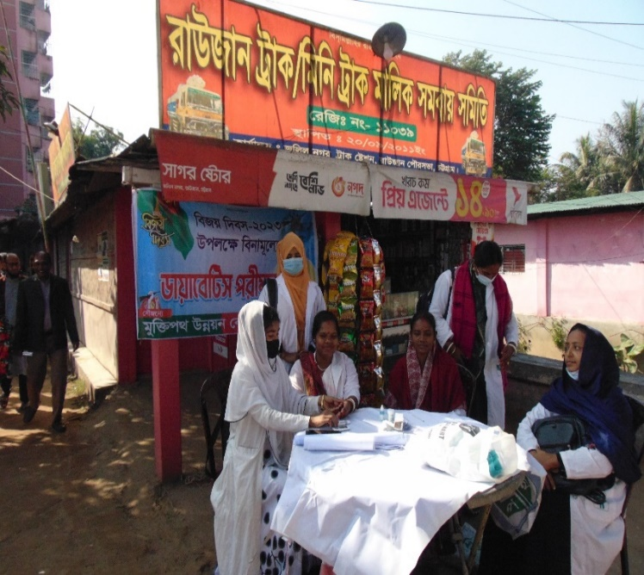
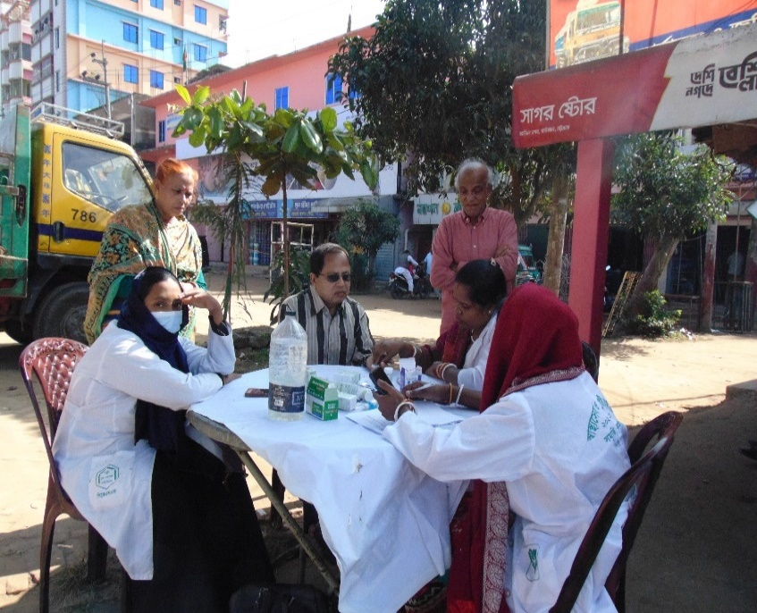

Free Diabetics Camp
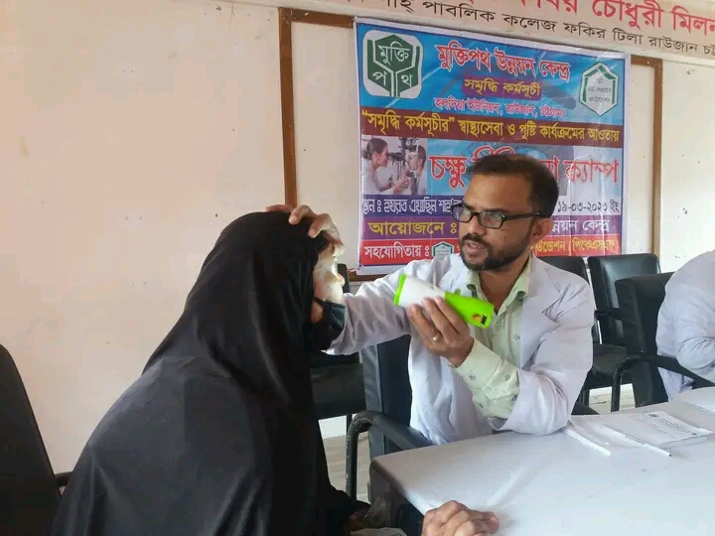

Free Eye Treatment Camp

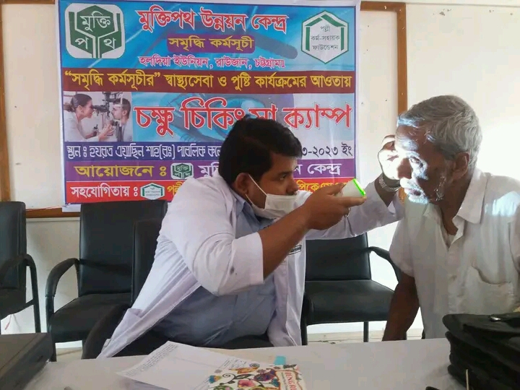

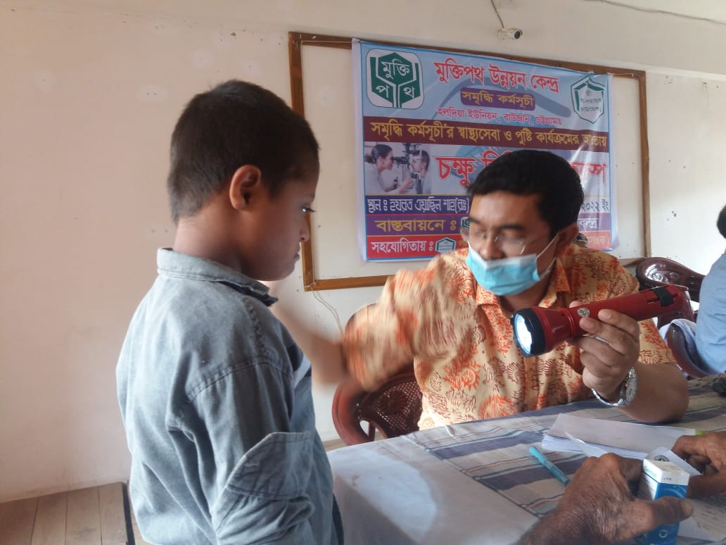

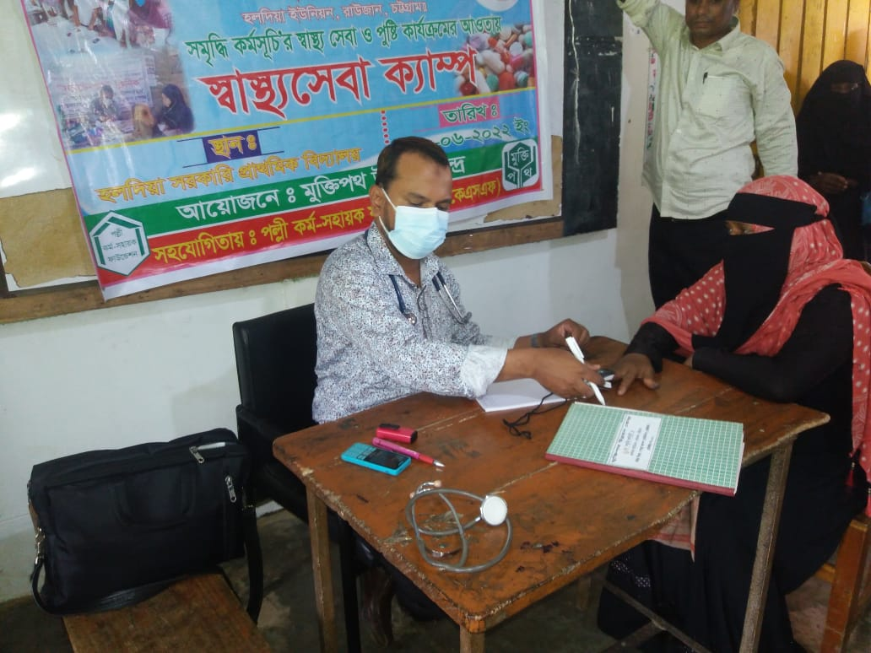
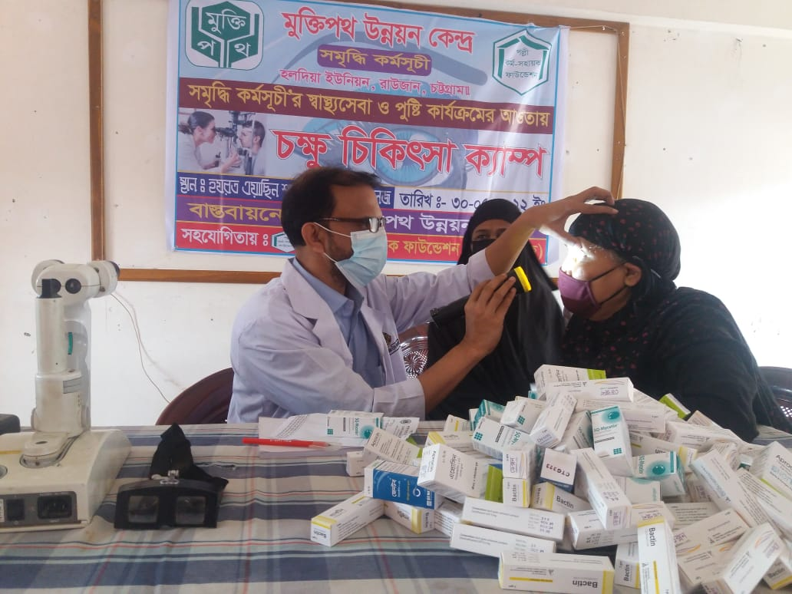

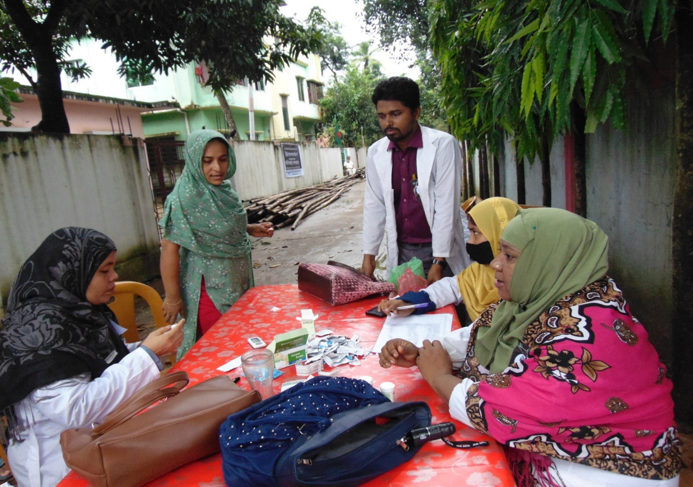

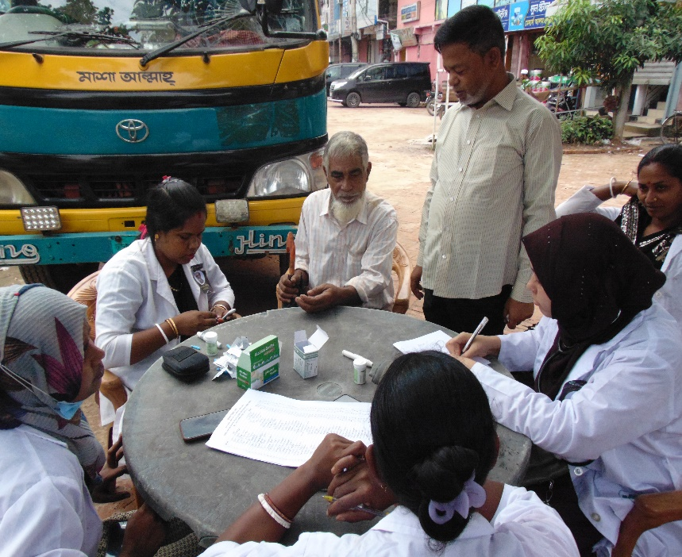
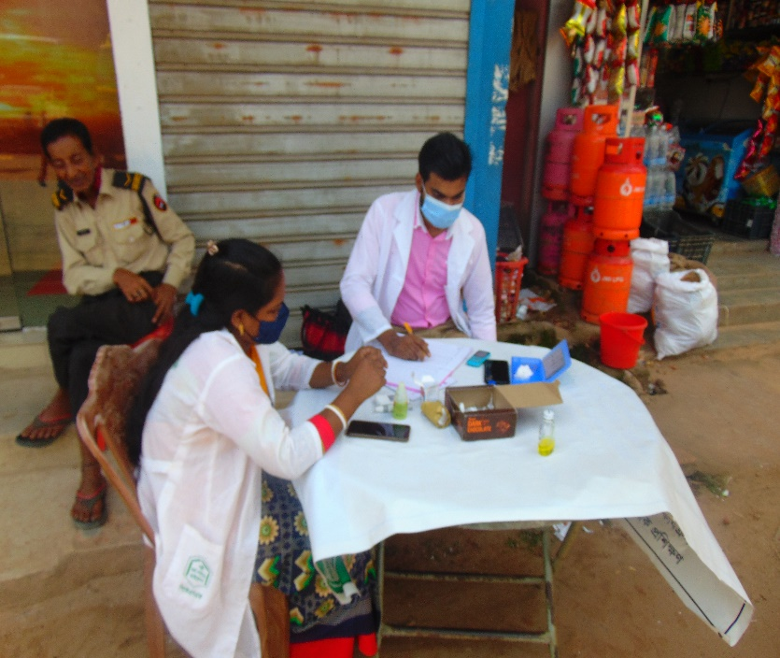

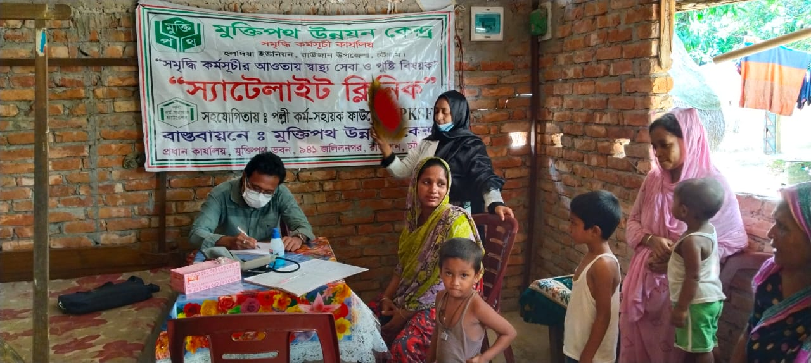

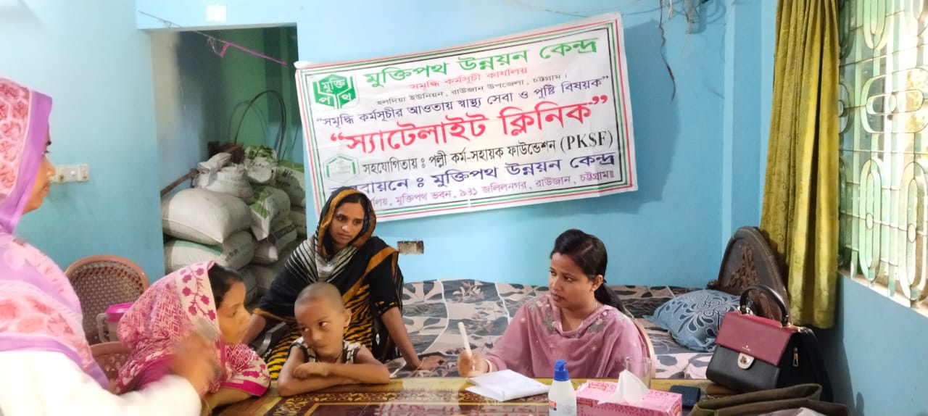

Free Satellite Activities
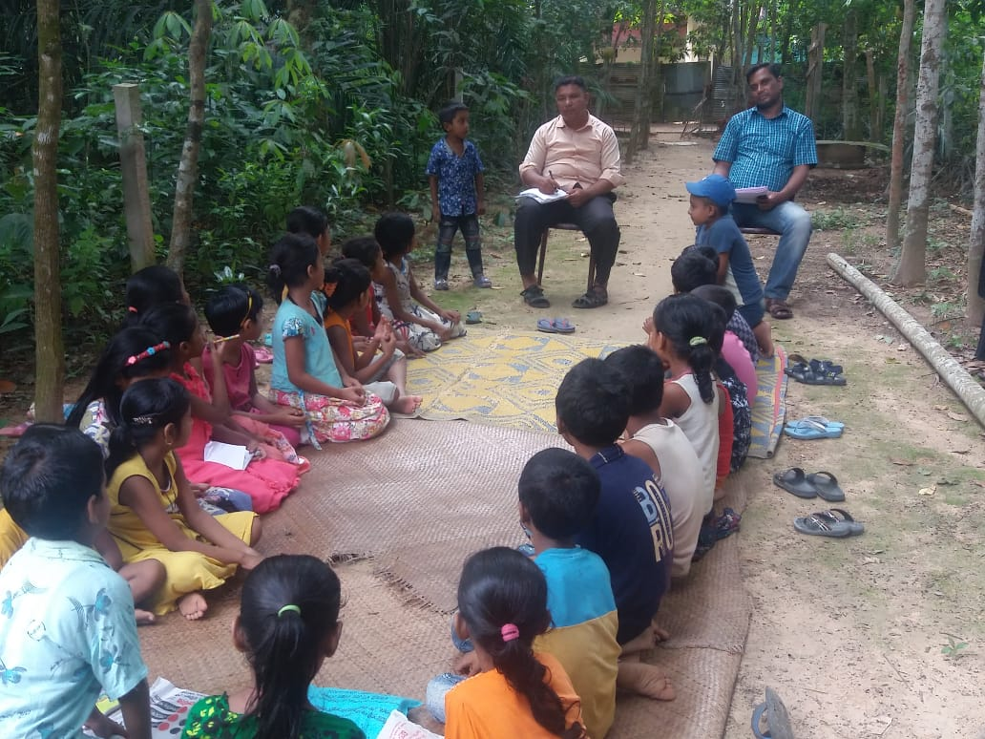

Sports and Cultural Events

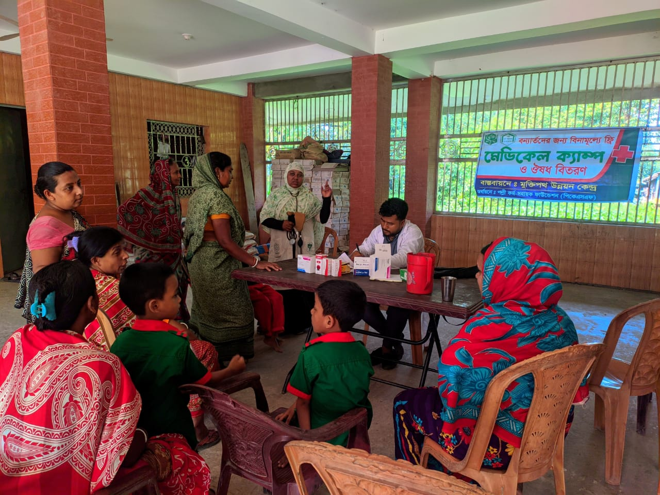
Free medical camp among the underprivileged

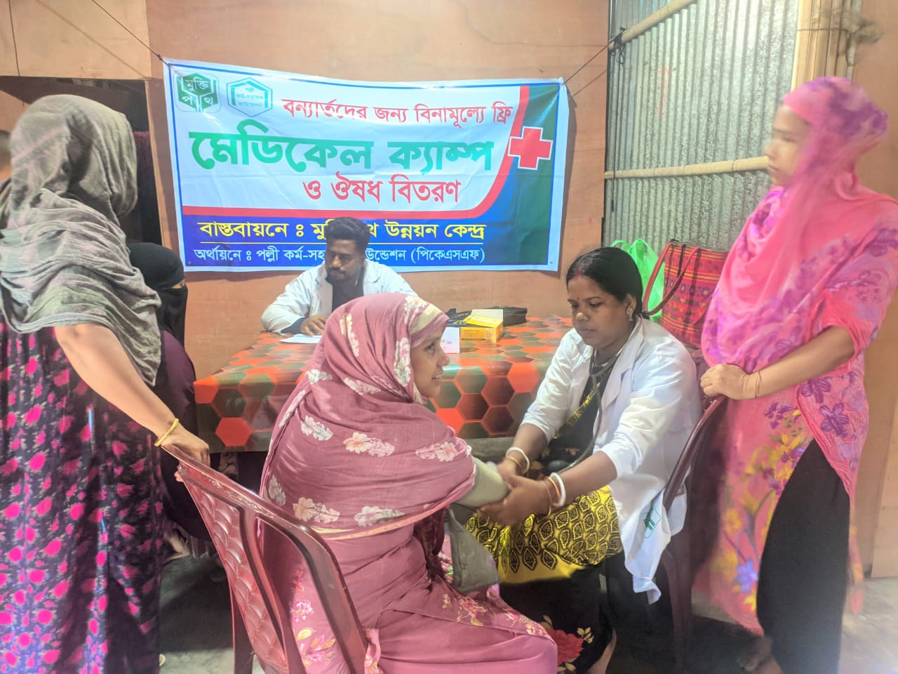

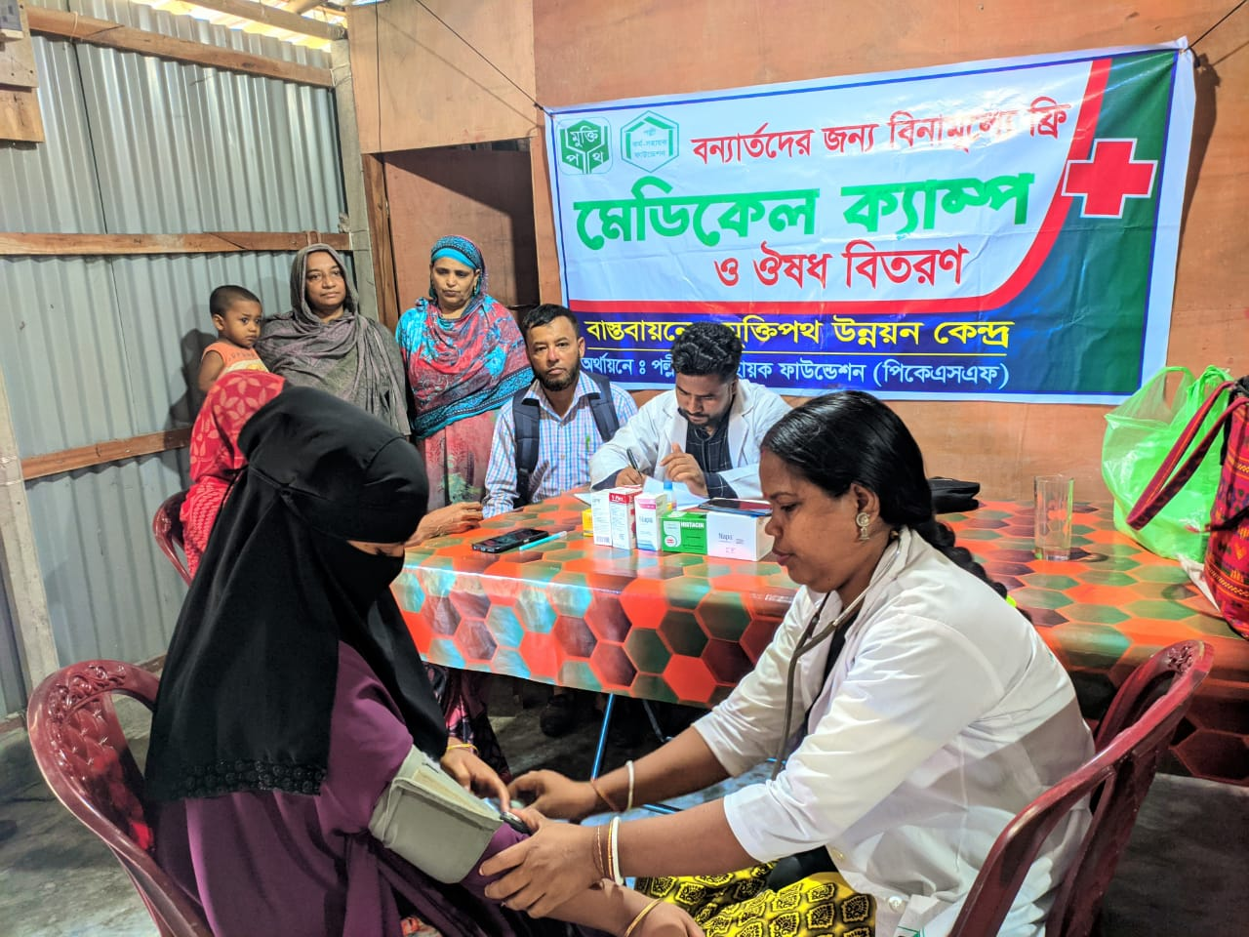

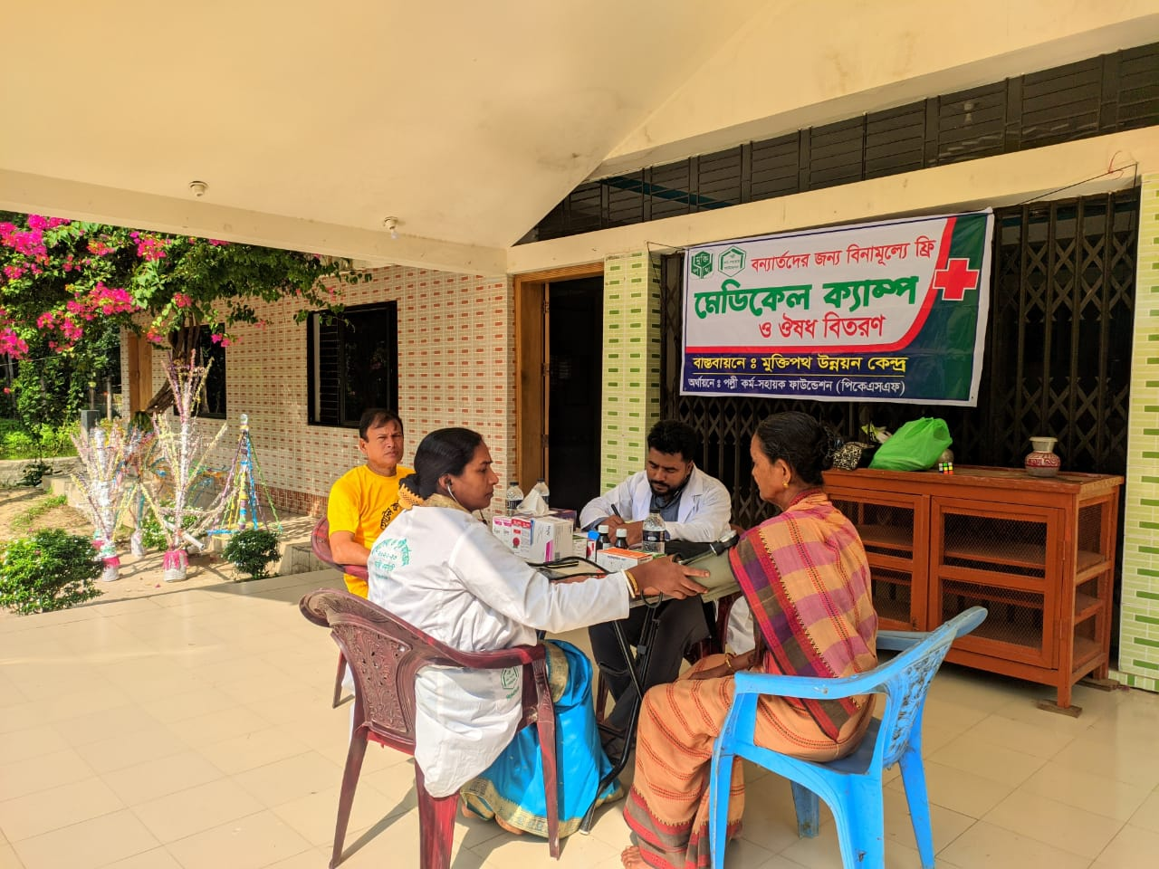

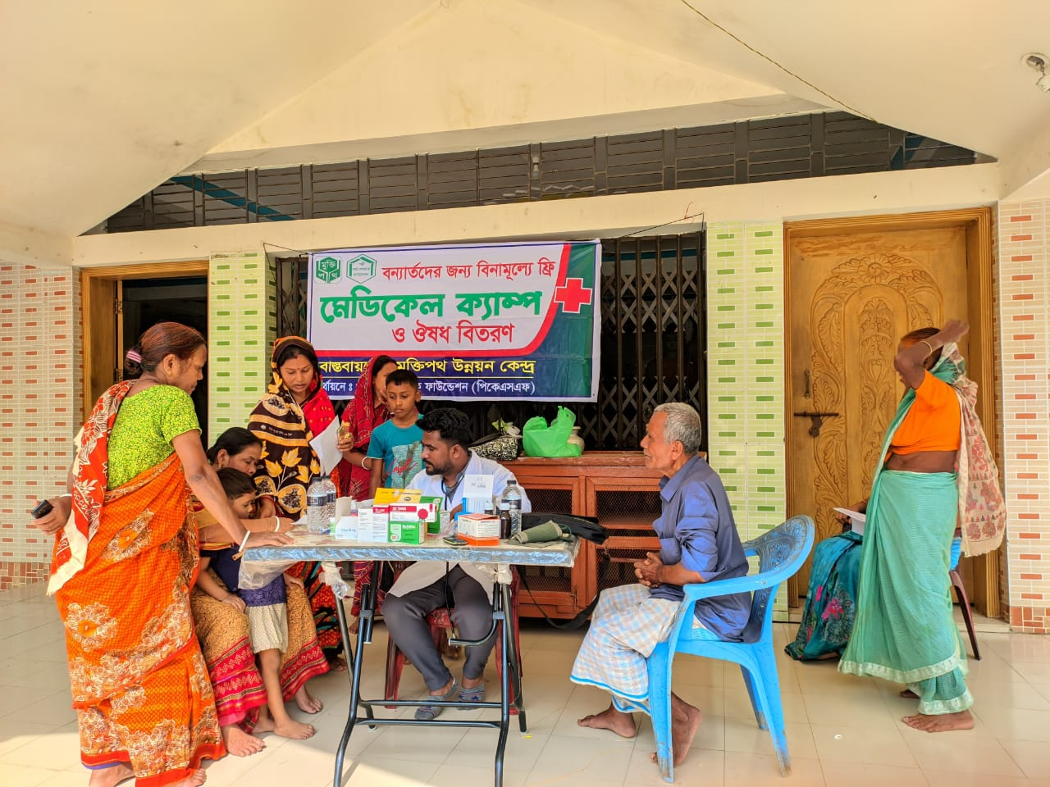

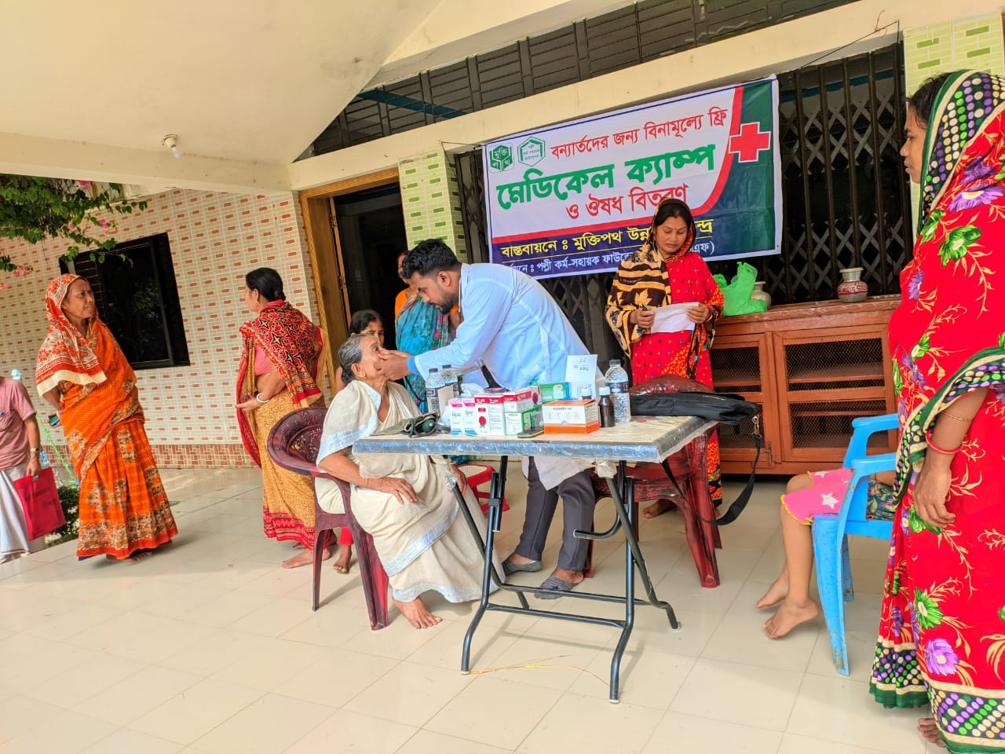

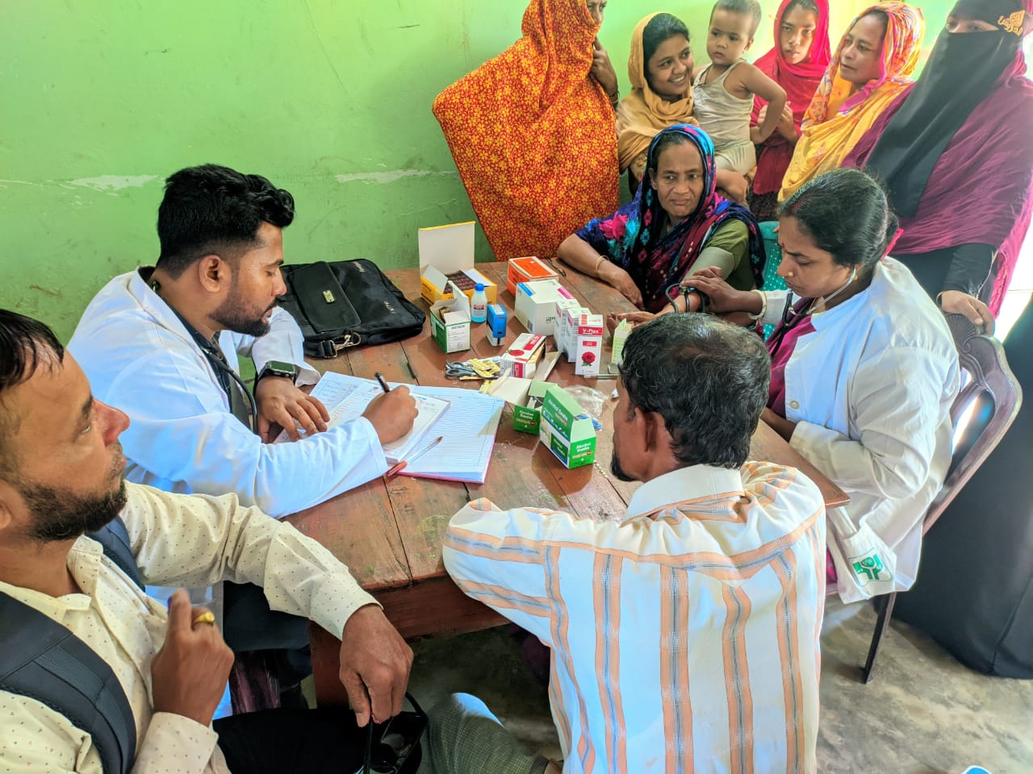

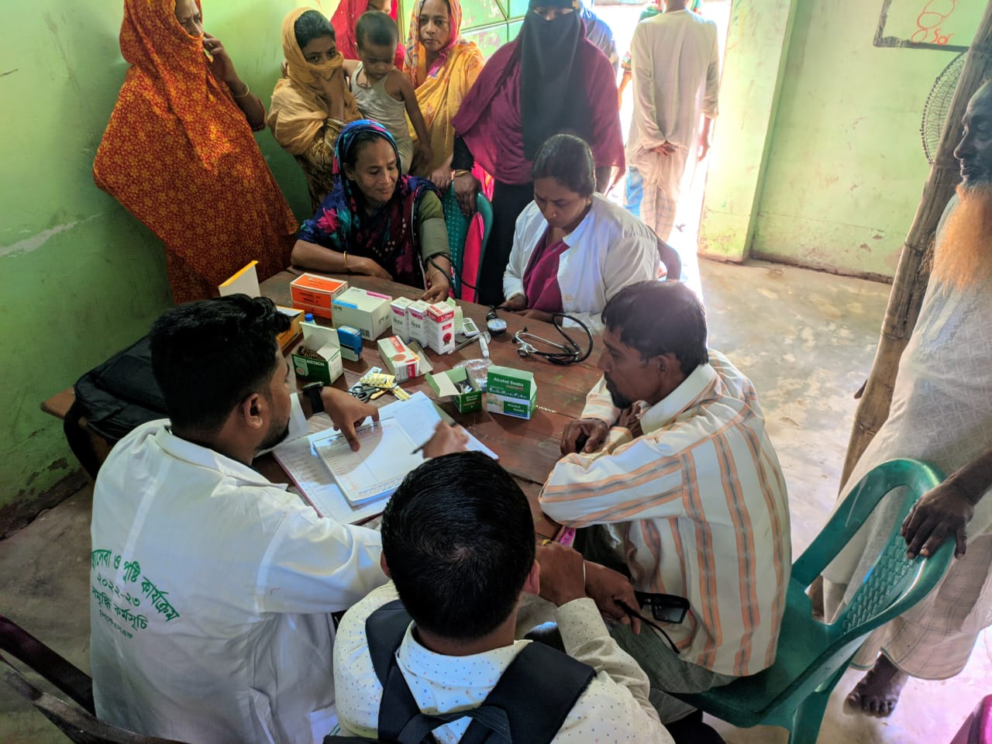

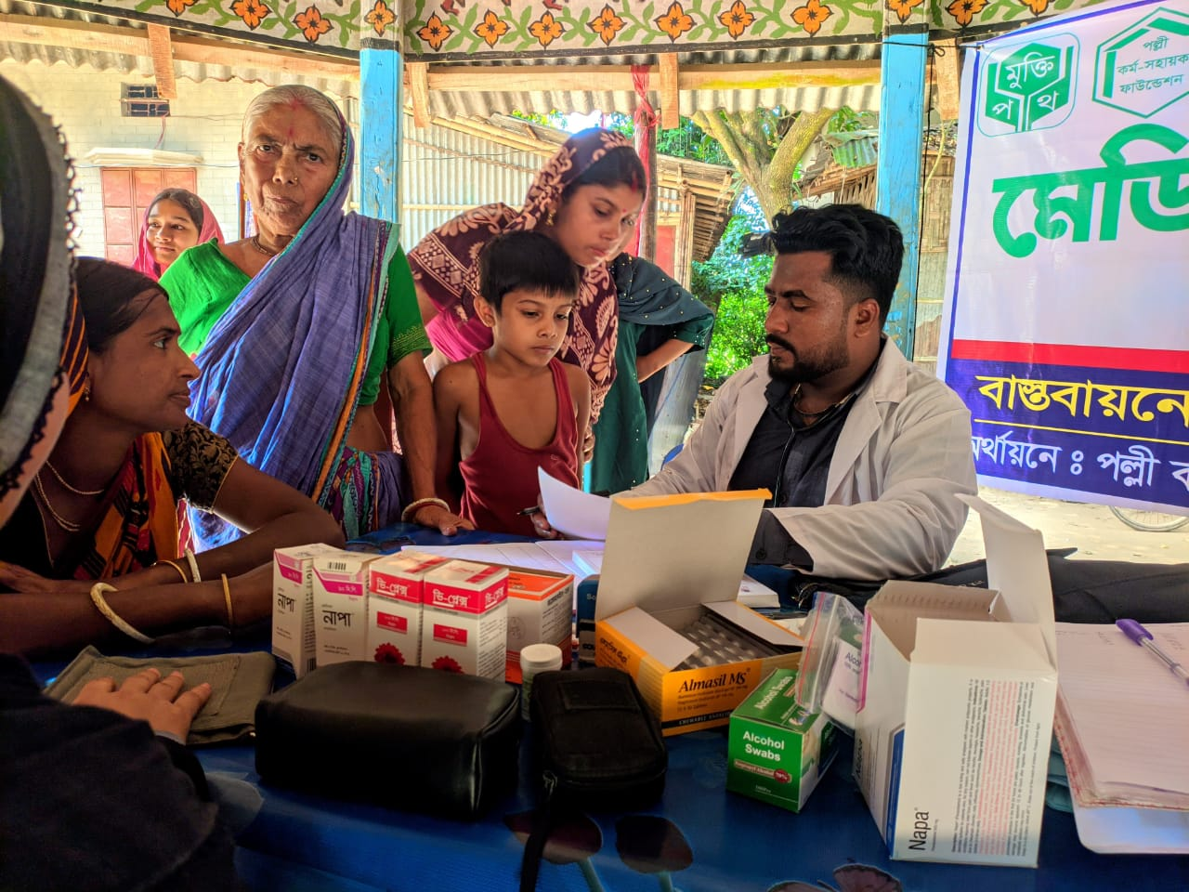

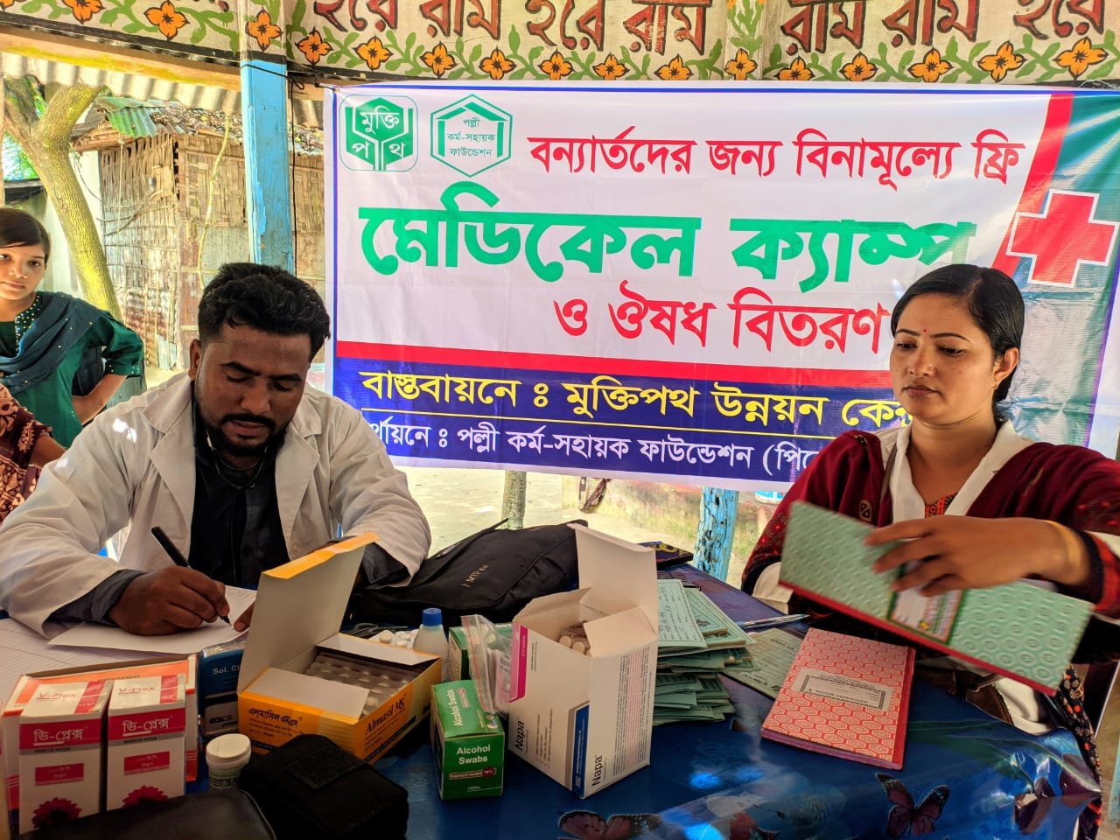

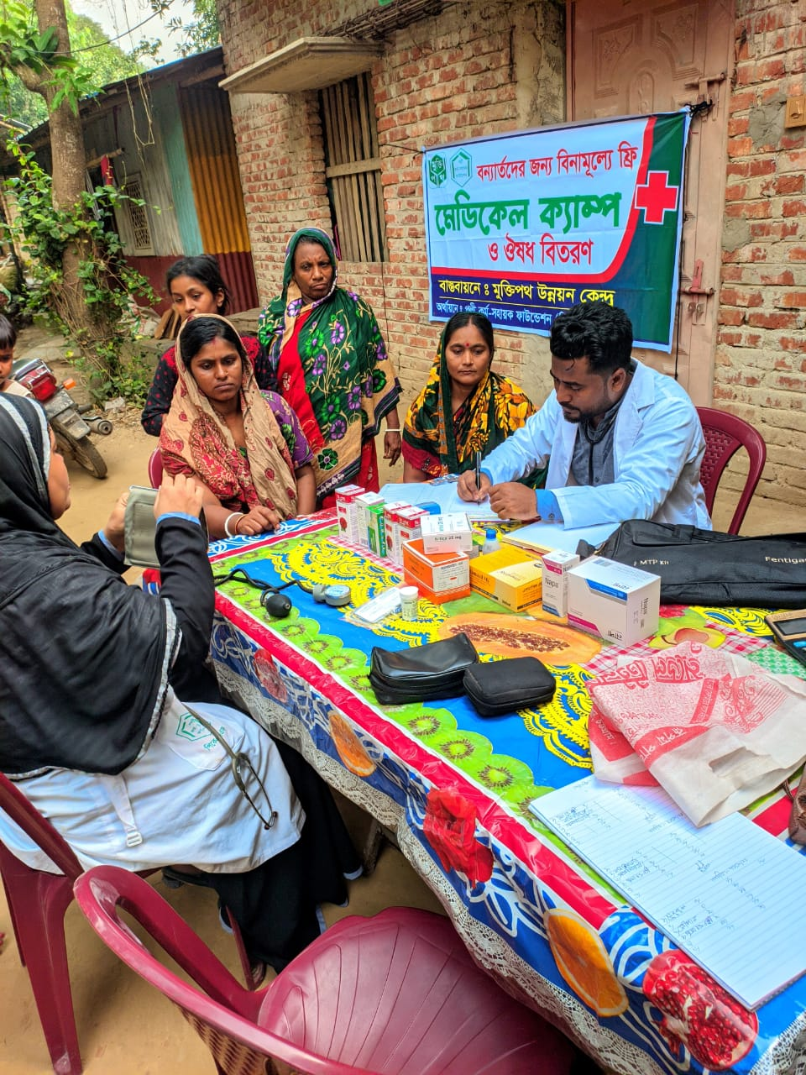
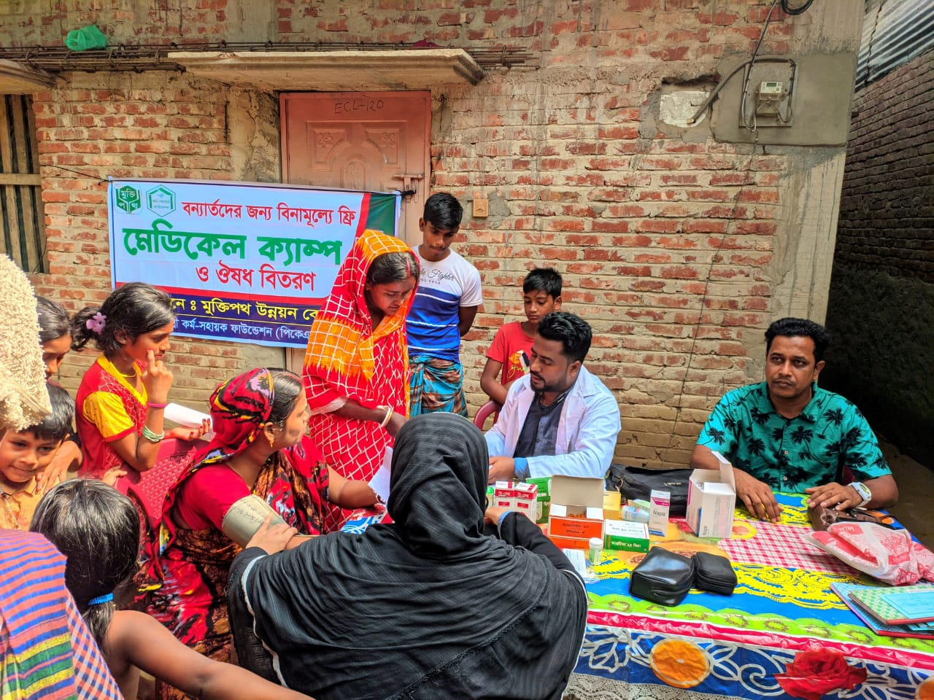

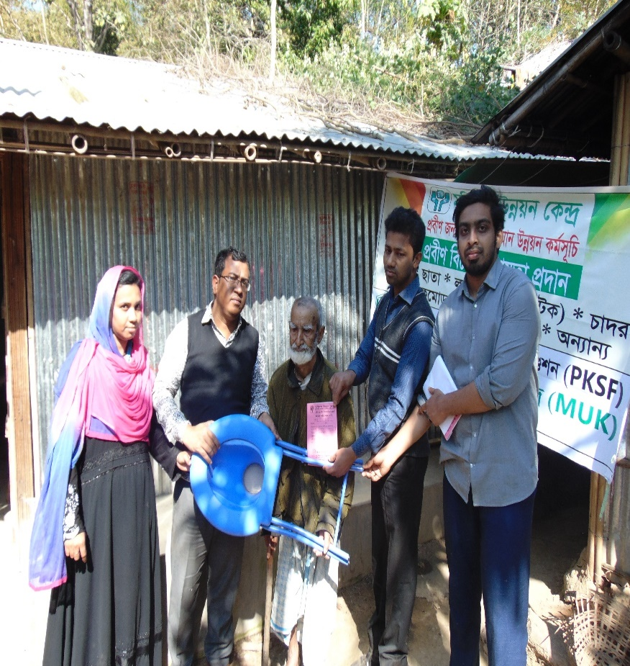
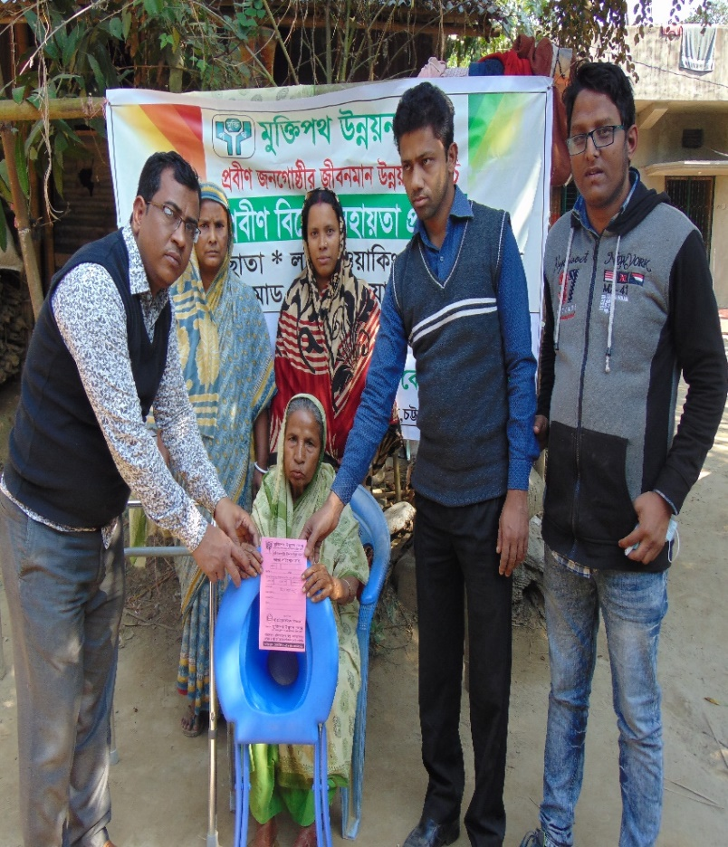

Free distribution of commodes among the needy
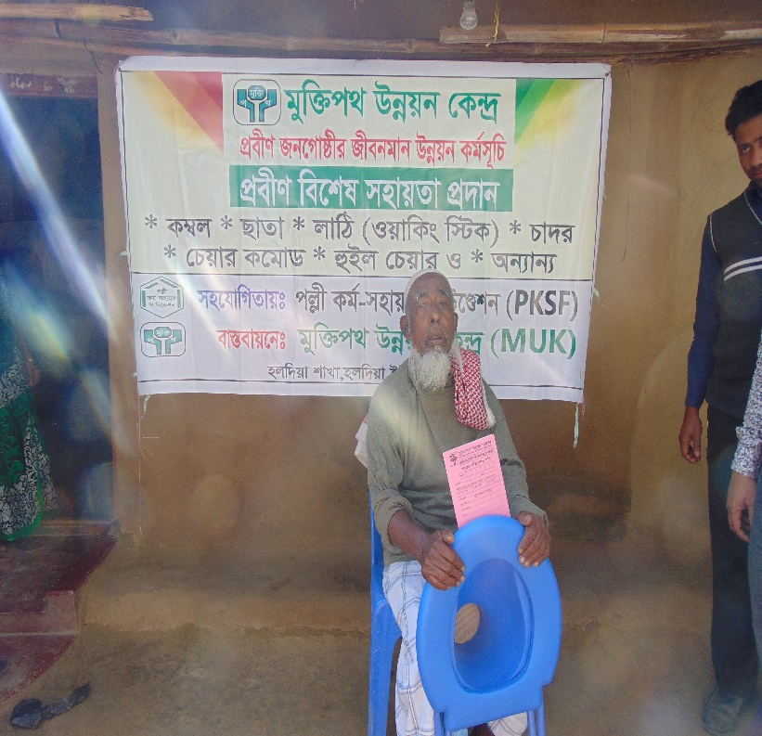
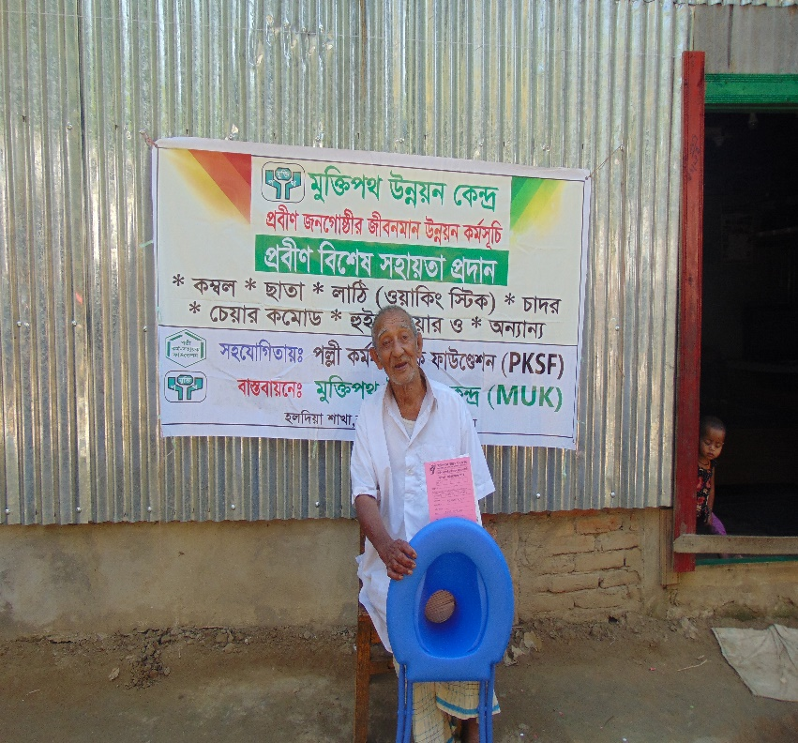

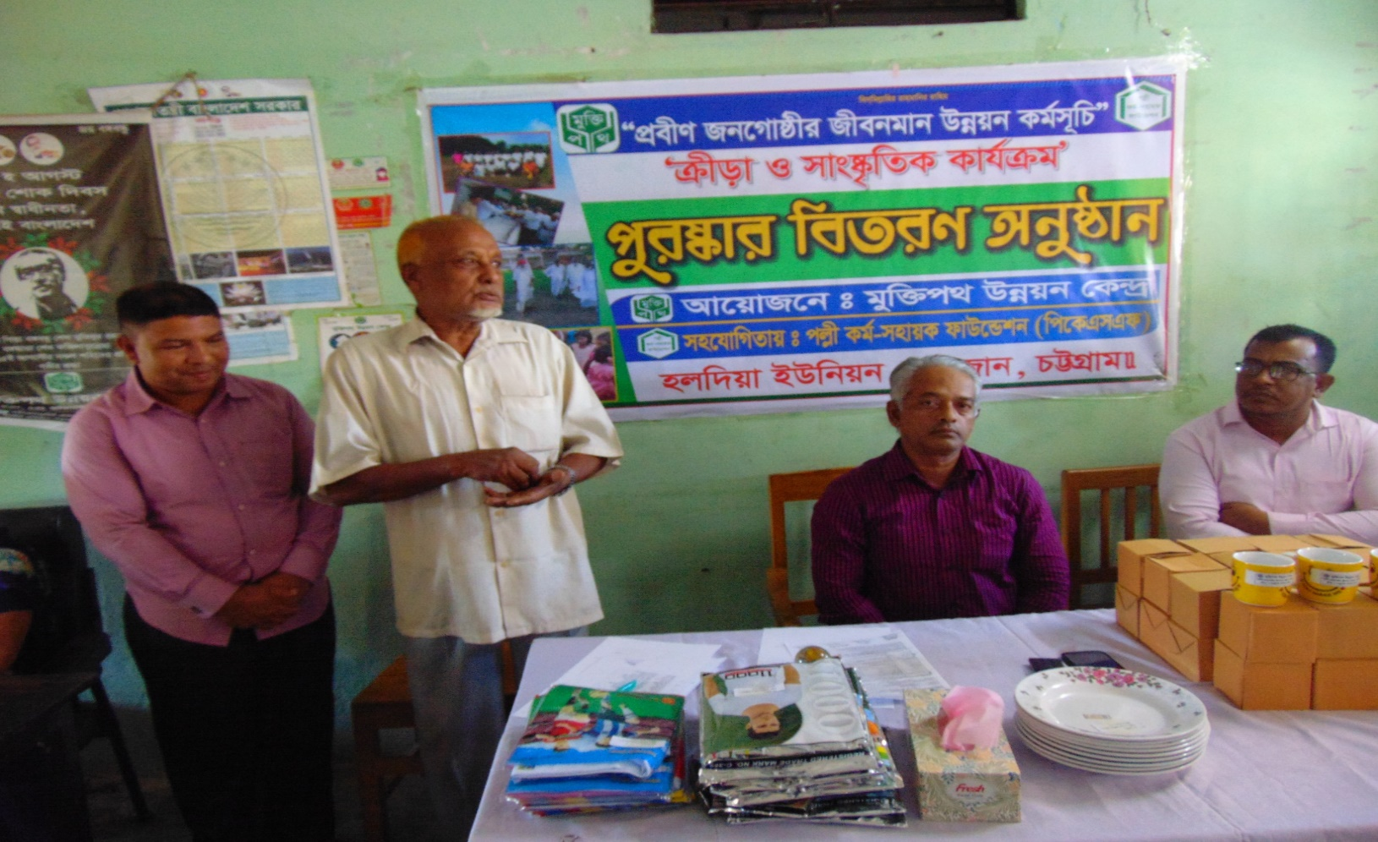

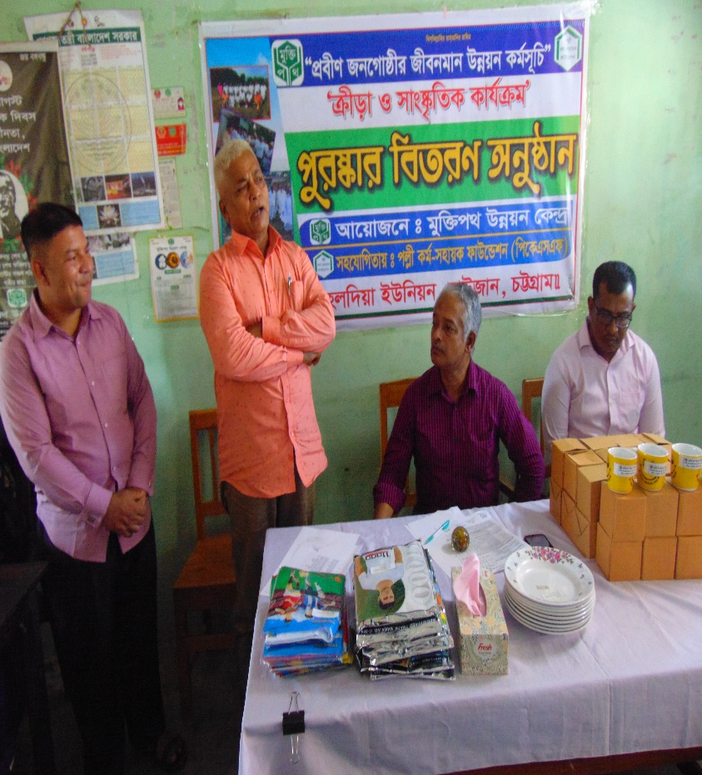
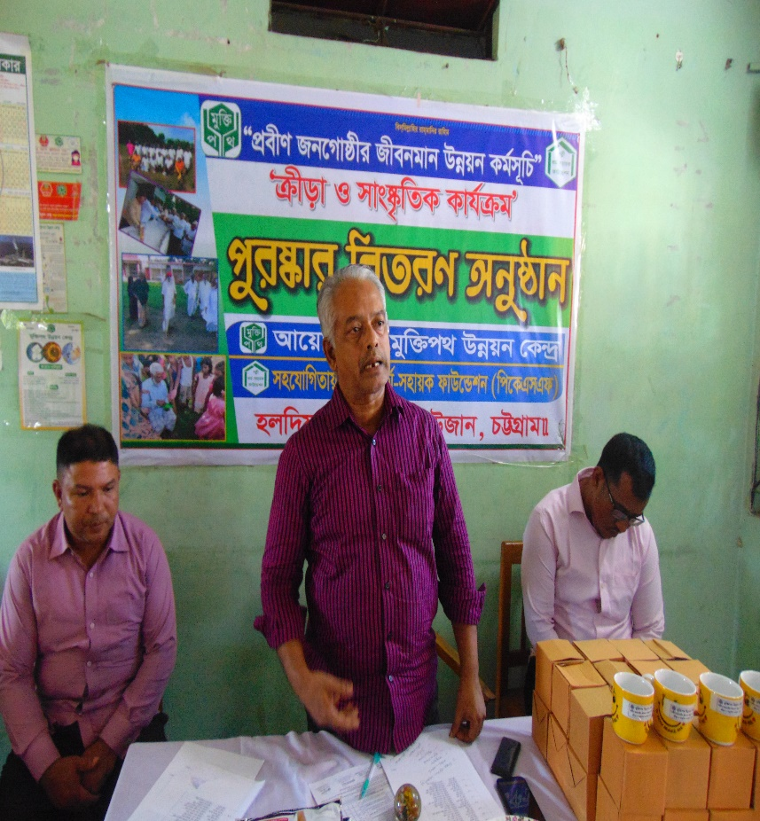

Senior Citizen Quality of Life Improvement Program
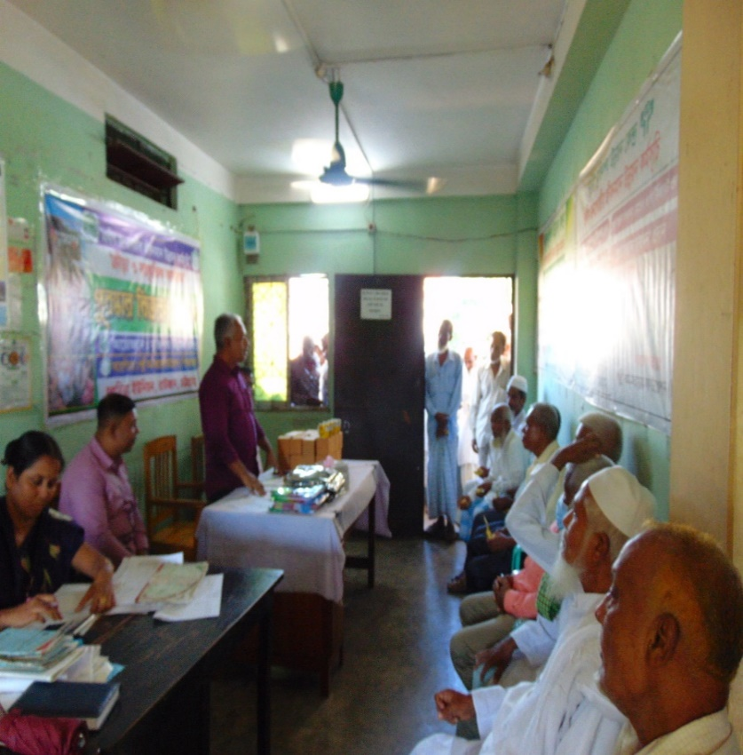
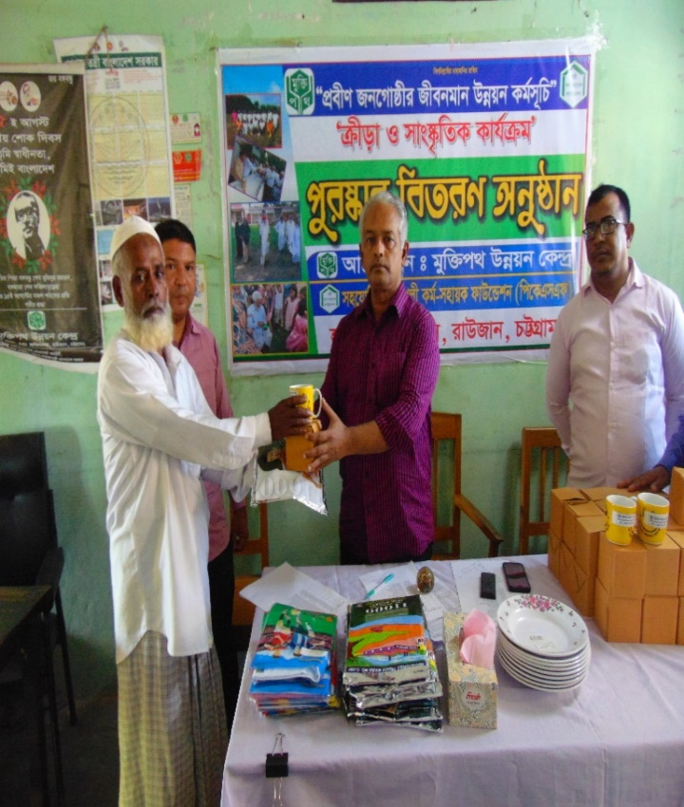

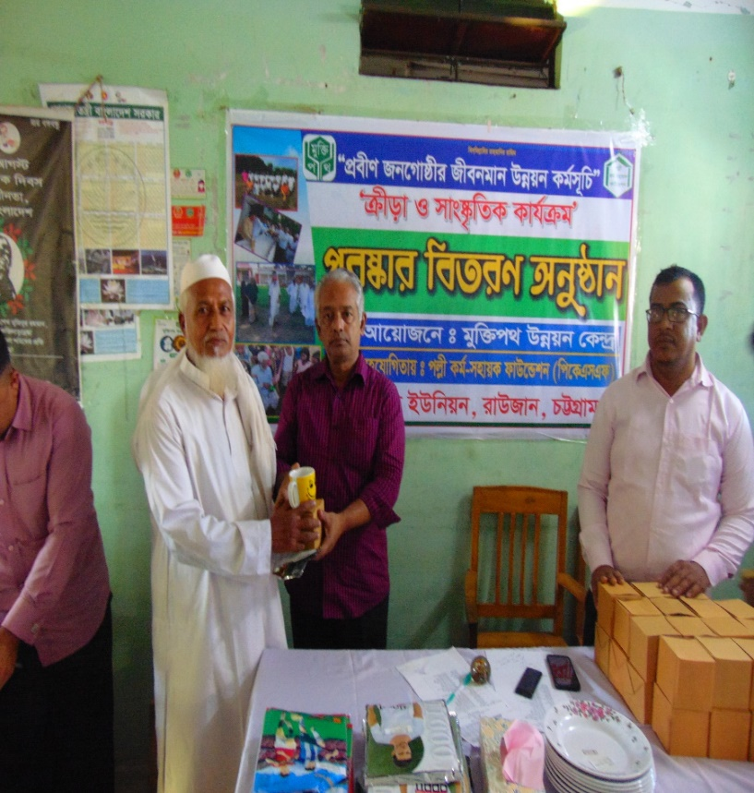
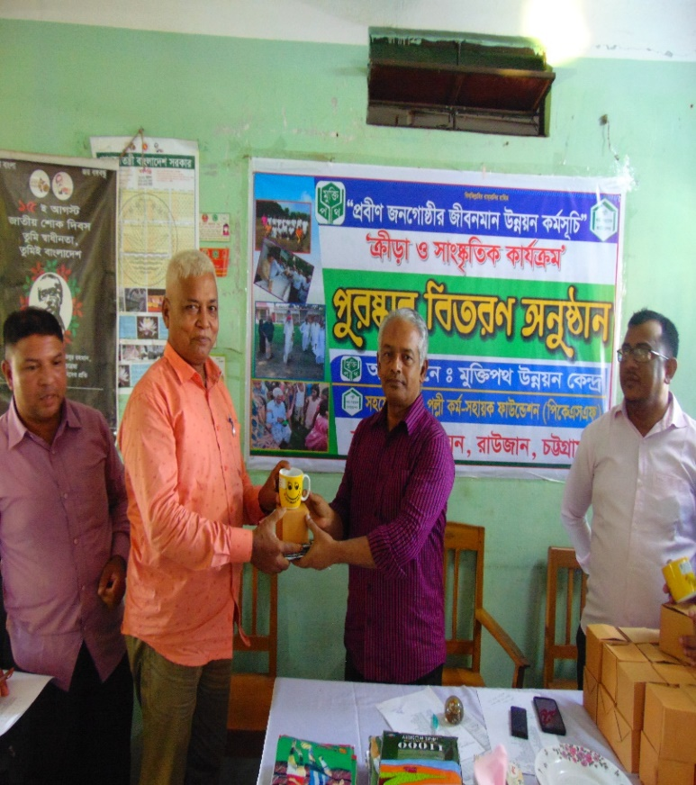

Sports and Cultural Activities
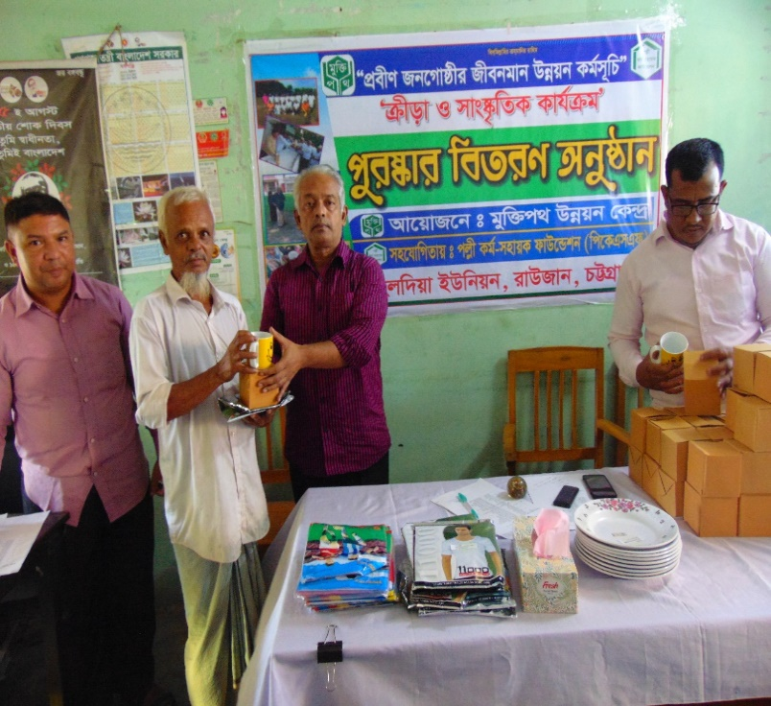
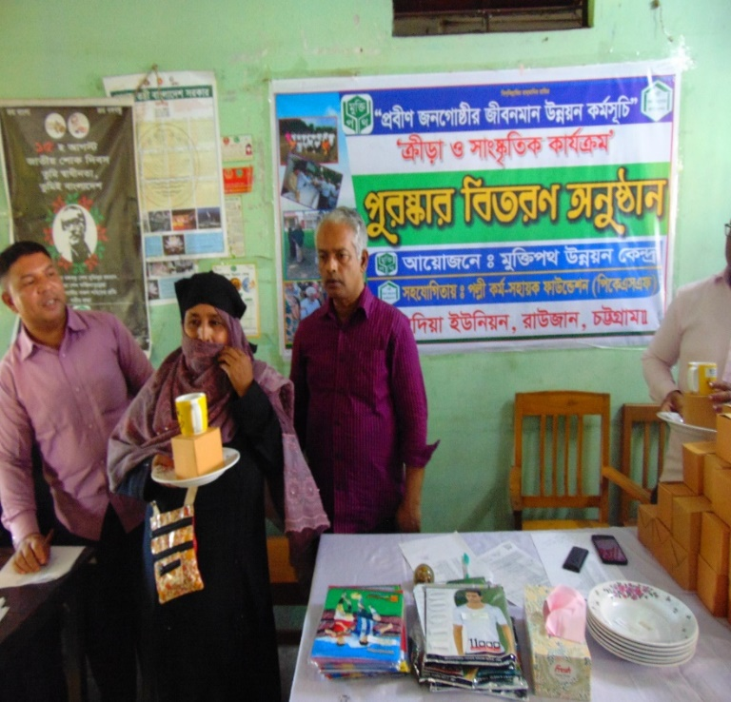

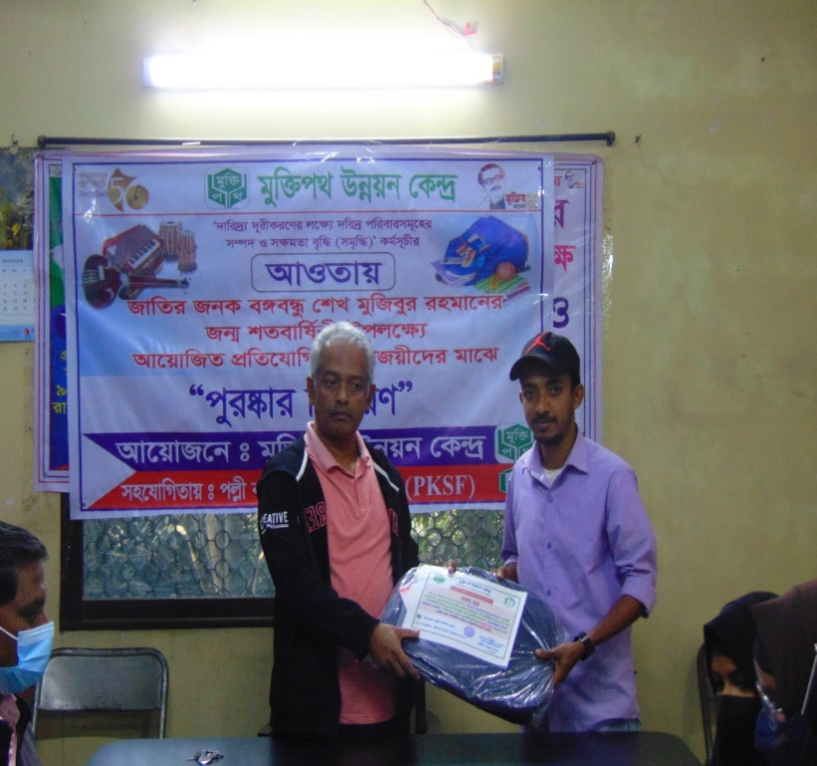
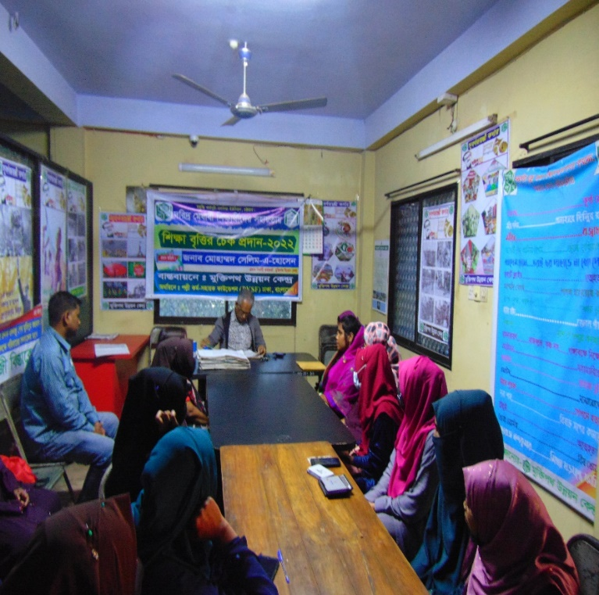

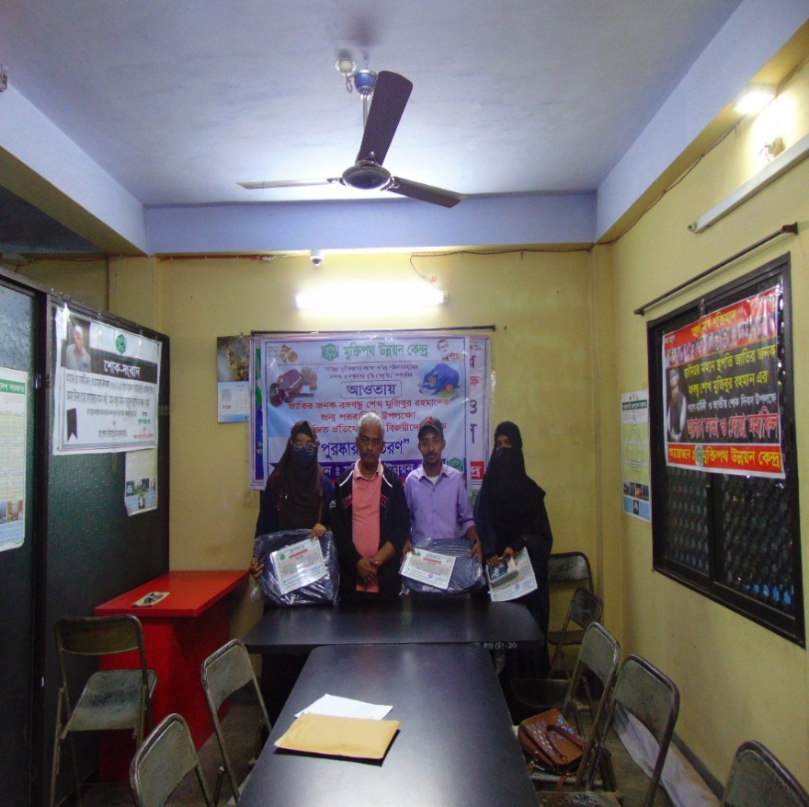
Award Ceremony
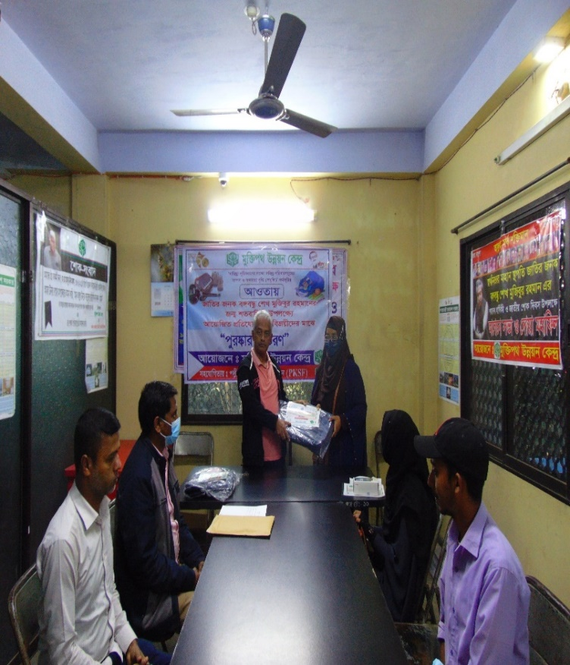

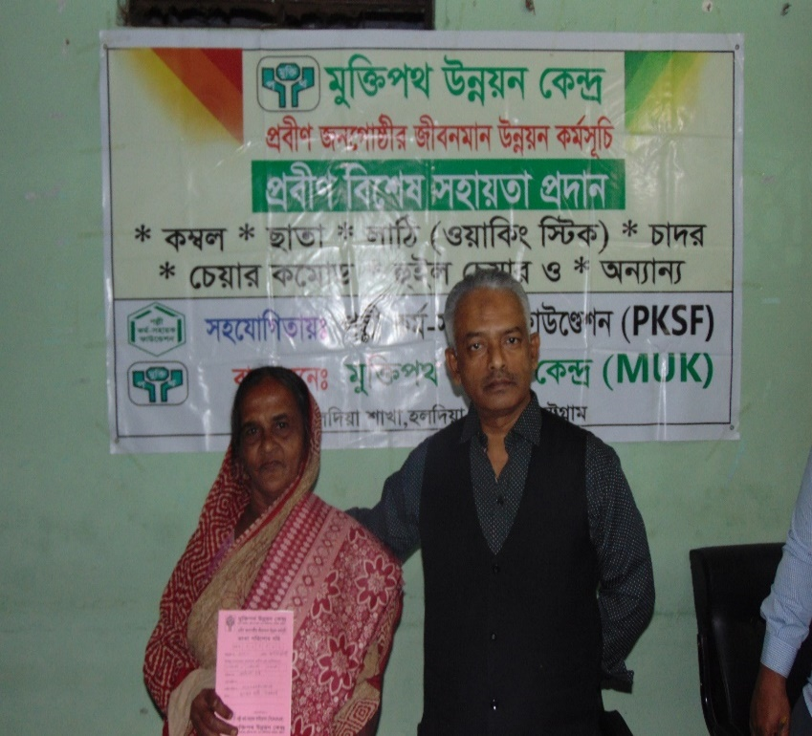
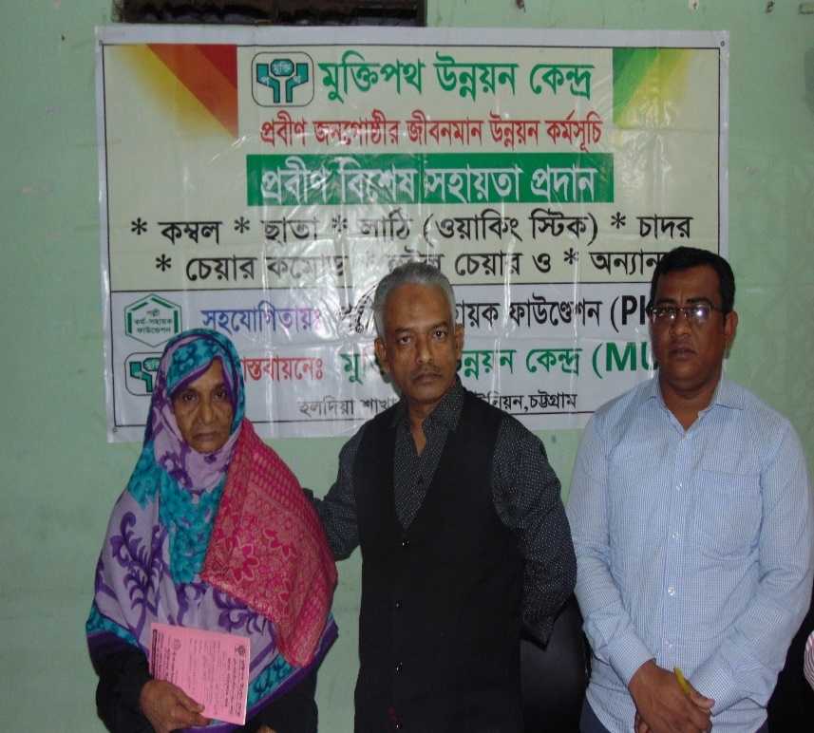

Free winter blankets distributed among the needy
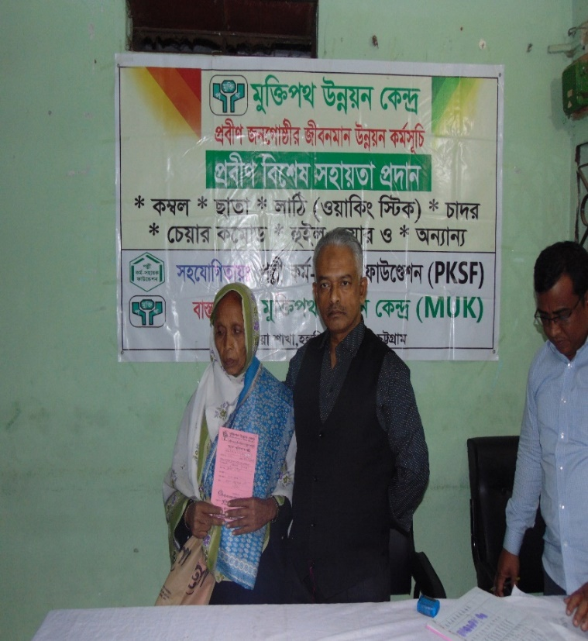
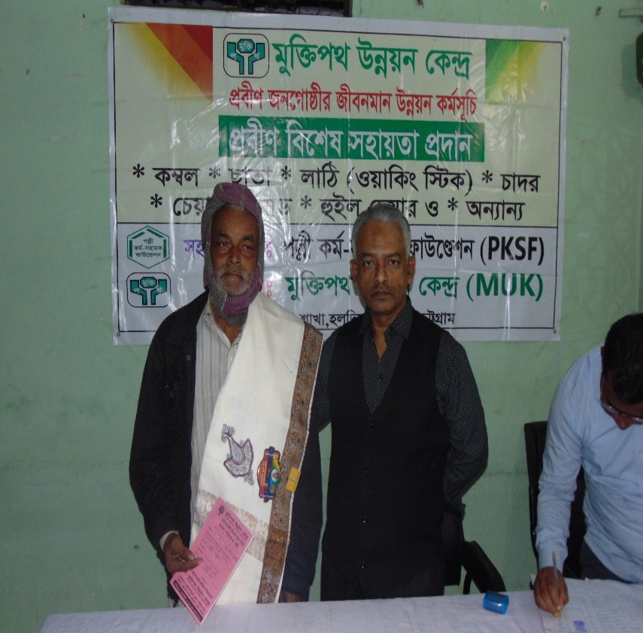

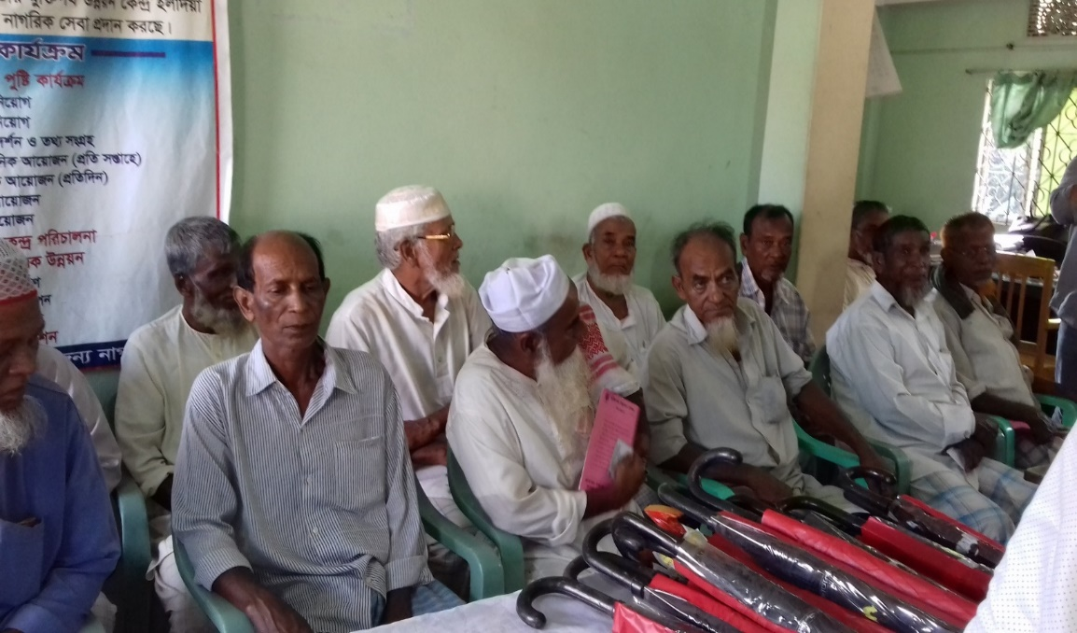

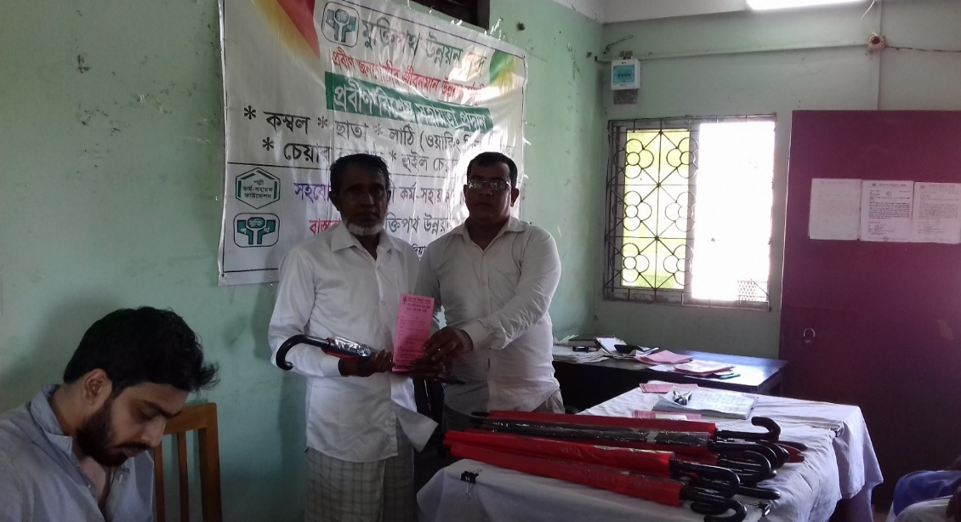

Umbrella distribution among the needy
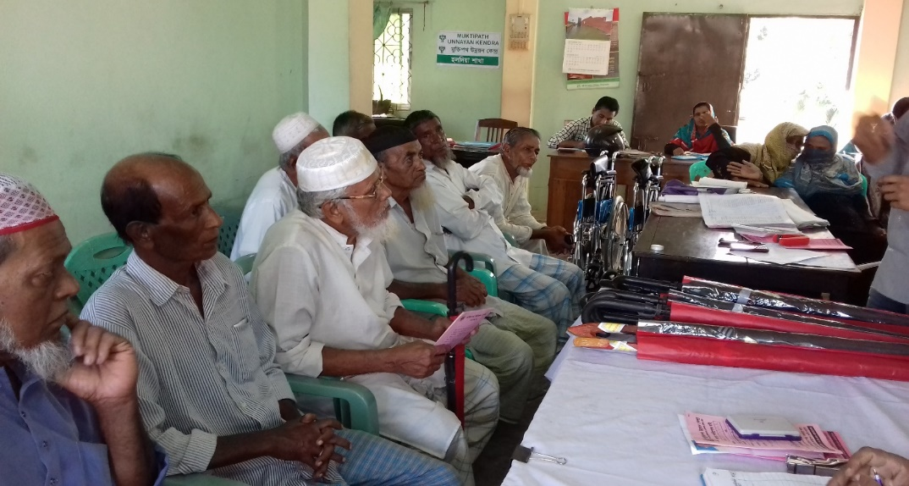

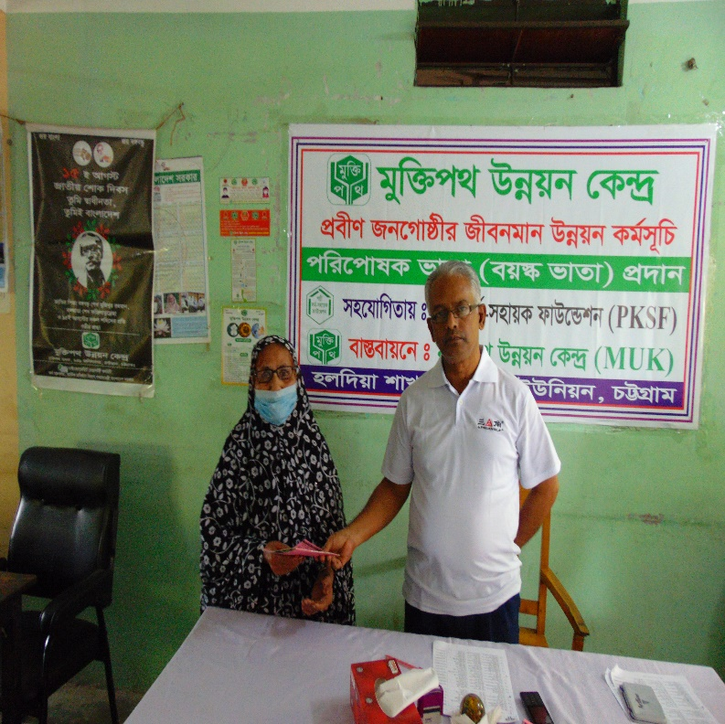
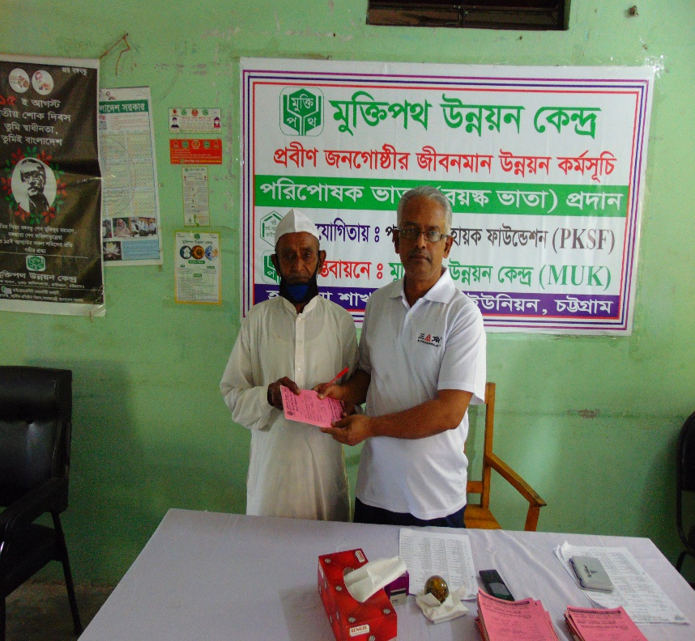

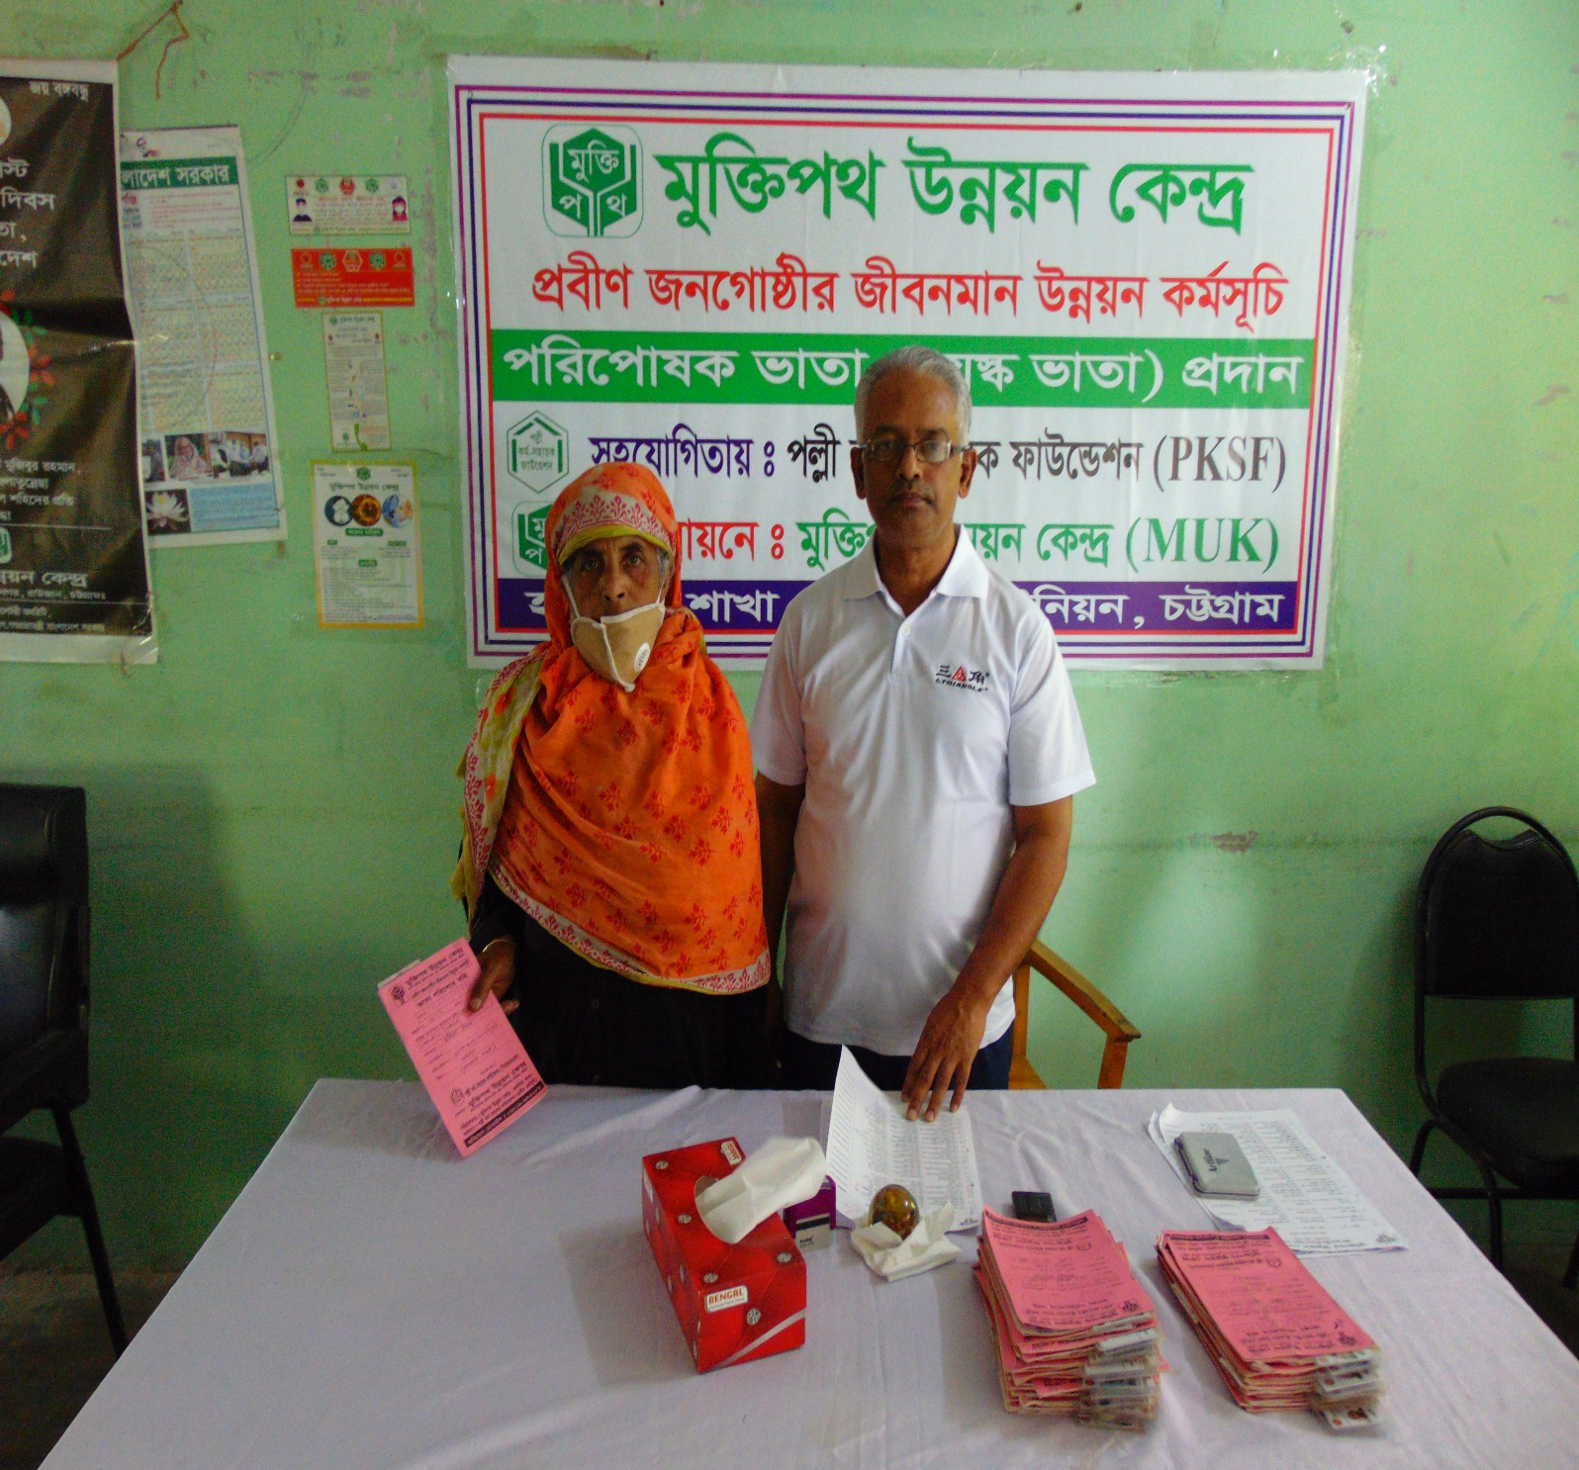
Providing maintenance allowance to the helpless poor people

